LinkedIn profile – Akane Kawaguchi

Akane Kawaguchi is a postdoc in the lab of Elly Tanaka and has been investigating the epigenomic regulation of regeneration in the axolotl. This summer, after five and a half years at the IMP, she will take up a new position as Assistant Professor at the prestigious National Institute of Genetics in Japan.
---
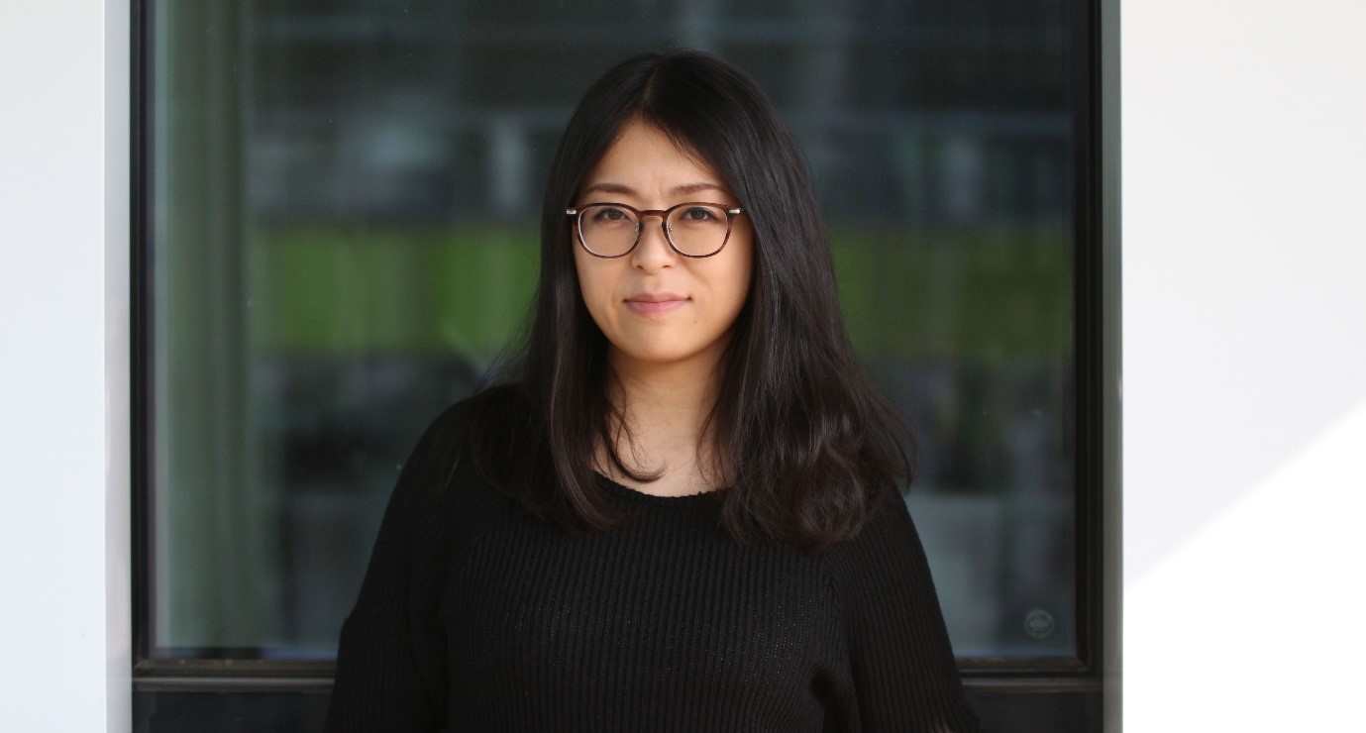
---
Making it through the stages of an academic career can be very challenging. How did you land that new position?
My new PI, Professor Dr. Shigehiro Kuraku was advertising his assistant professor in which he is moving to new place. But I only knew Dr. Kuraku by name at that point, because he used to be a group leader at Riken. He was very interested in work on the large genomes of the lungfish and the axolotl, and I found the opportunity to apply for the position. I thought it would be nice for updating my expertise to work as an assistant professor to help him set up his new lab. Elly was very supportive as well, knowing how rare such opportunities can be.
What is your job going to look like?
Assistant professorships in Japan are different from what they are in Europe. In Japan, assistant professors work for a full professor who has most of the decision power. Dr. Kuraku is an evolutional biologist who is approaching to the question from the computational and theoretical aspects, and he wants to combine his expertise with my extensive experience of wet lab experiments. we’ll combine and share our knowledge to address scientific questions from two angles. I’m very excited about this setup.
What do you plan on investigating?
The overarching theme of my research will be genome evolution, and for that I will use vertebrates model system including sharks as well. I would like to tackle this big theme through mainly two topics. The first one is the evolution of genome size. I have worked on the axolotl genome for years now, and more recently on the genome of the Australian lungfish – two species with enormous genomes. The genomes of sharks are relatively big, too - about twice as big as that of humans, and three to five times that of bony fish species like the zebrafish and more than the pufferfish (400Mb). I would like to figure out why some genomes expand to such costly sizes, while others are reduced to the minimal functional size.
In addition, I would like to tie in what I have done in Elly’s lab in regeneration biology with my upcoming research. Humans don’t have good regeneration abilities, but bony fish and some amphibians do. It’s possible that the first vertebrates had good regenerative abilities – but that would mean that many vertebrates have lost them along the way. The question is: why? Sharks hold an interesting position on the tree of life – their branch separated from other fish early in the evolution of vertebrates. No one knows if sharks can regenerate or not, and I’d like to test it, possibly drawing links to their genome.
You have reached a critical point in an academic career, the stage right before becoming a full professor. How did you get there?
I graduated from the Nagahama Institute of Bio-Science and Technology in Japan in 2009. For my bachelor’s thesis, I worked with Professor Shuichi Wada to investigate the genome regulation of Ciona, a genus of sea squirt and a cousin of vertebrates. I then moved to the Nara Institute of Science and Technology for my master’s degree in genomic regulation with Professor Hajime Ogino. After that, I was not sure whether I should follow the academic track or not. Japanese society doesn’t have the appreciation for doctoral degrees that Europeans do. Having a PhD can decrease your chances of being hired outside of academia – you may be considered too old and too expensive to be recruited. That’s why relatively few people do a PhD in Japan, and those who do usually have a precise goal in mind: to pursue an academic career. That wasn’t me – and yet I decided to go with the flow and follow my interests, so I did a PhD with my master’s supervisor, working on the epigenomics of lens development in Xenopus and, as a second project, on tail regeneration. He had a lot of collaboration requests, and I was able to use my expertise on transgenics to work on a variety of projects with collaborators.
In 2014 I finished my PhD, and again I wasn’t sure about the future, whether I should continue in academia or not. I ended up staying in Nara as a postdoc and teaching assistant for a year and a half. Teaching classes of 60 students was a good experience, but I knew I had to move on. After seven years with the same supervisor, I wanted to see something new and focus on research. That’s when I met Elly Tanaka. I knew her work on cell fate during limb regeneration, but I hadn’t considered working with her because of the daunting perspective of moving abroad. Then I met her at a conference in Japan and our research interests clicked. I applied for a postdoc fellowship in Japan and got it. That was only funding for six months, but I decided to take it and moved to Dresden, Germany, where Elly was back then. I was ambivalent about the future, but I took a risk – who knows what can happen within six months?
Two months after I moved to Dresden, I received more funding for three years (with two different grants), and Elly took care of the rest of my funding until now.

You will probably have to supervise students in your new role. What qualities should a good mentor have?
Patience, clear decision making, and the ability to give useful feedback would be my top three. I have a person in mind – my colleague Katharina Lust, with whom I have the strongest connection at the institute. She is extremely patient and fair. She is quite direct, but always gives good and honest feedback. I trust her to always have my best interest in mind. For me, she is a role model – and a very promising scientist.
What challenges do you imagine in your new role?
A postdoctoral researcher can focus on science, and a professor is more of a manager and has all the decision power in the lab – as an Assistant Professor in Japan, I will have an unusual intermediate position, following my boss’ instructions while managing the wet lab.
I’m sure I will face a lot more challenges that I can’t think of yet. One challenge I have started to tackle from the start is to establish honest, clear, and direct communication with my boss. I think this is crucial for a team to work together successfully.
Any word of wisdom for postdocs who are hesitating to stay in academia?
I think it’s important for academic researchers to be honest about their story. I did not have a clear path to an academic career, and I doubted it many times. There were times where I had no idea what the future would look like, but I stayed optimistic. When I went through confusing times, I kept focusing on the here and now and trusted that the future would be okay. The key message here is: stay open to opportunities when they come your way and work hard to seize them.
---
If you are interested in Akane’s work, you can contact her by email at akane.kawaguchi[at]imp.ac.at.

