**Beyond marginal: Estimating the demand for water quality**

David Wolf[1]*

Kobe University

H. Allen Klaiber[2]**

The Ohio State University

Sathya Gopalakrishnan[3]**

The Ohio State University

**Abstract**

Using micro-level data across Wisconsin covering over 100 inland lakes, we recover first- and second-stage hedonic welfare estimates for non-marginal changes in water quality. We overcome longstanding endogeneity concerns with Rosen (1974)’s second stage hedonic framework and recover slope estimates for water quality demand using instruments based on sorting behavior. For near lake Wisconsin households, we find the slope of their water quality demand function is bounded by -2,087 when imperfect instruments are employed, which is significantly more price inelastic than the naïve OLS estimate of -895. Applying these estimates to a hypothetical policy scenario where water quality reduces by 24.2% due to a 30-year continuation of current trends, we find welfare losses of at least $7,554 per household. These losses are 22% ($1,658) more than what is predicted from marginal willingness to pay estimates recovered from the first-stage hedonic. For policymakers, our results highlight the importance of recovering underlying demand functions when evaluating non-marginal water quality improvements.

**Keywords:** Inland lakes; property values; second stage hedonic; water quality; willingness to pay

**JEL Codes: Q51, Q53, Q57, Q25**

**Beyond marginal: Estimating the demand for water quality**

1. **Introduction**

Freshwater lakes across the United States have experienced large, non-marginal changes in water quality in recent years. Harmful algal blooms have polluted lakes and public water systems by releasing freshwater toxins like *microcystin* and *anatoxin* into the water (Wolf and Klaiber, 2017). Sewers have flooded waterways with industrial chemicals and residential waste during major storms (Marsalek et al. 2004; Guilfoos et al. 2018), while agricultural runoff has significantly affected fish populations by depleting oxygen from the water column (Steinman et al. 2015). These abrupt events not only reduce the aesthetics of the water but are a threat to public safety as drinking or swimming in contaminated water can cause skin irritation, respiratory problems, and even liver failure (Carmichael and Boyer 2016).

Many communities have experienced economic losses as a result of water pollution. Waterborne pathogens have decreased fishing permit sales and hotel revenue by as much as 13% and 15%, respectively (Wolf et al. 2017; Bechard 2019), while a season-long beach closure can cause up to $2 million in damages annually (Palm-Forster et al. 2016; Wolf et al. 2019). Municipalities bordering the Great Lakes have spent $1.7 million in additional operating costs each year in response to heightened contamination levels (Wang et al. 2019), while near lake residents have lost up to $25,000 in home value from a 10% decrease in water clarity (Poor et al. 2007; Walsh et al. 2011; Walsh et al. 2017; Liu et al. 2019).

In response to these economic losses, policymakers have focused on finding ways to limit non-point source pollution. Policies include converting ecologically sensitive areas into riparian buffer strips (Scavia et al. 2016), limiting fertilizer application on agricultural lands (Schindler et al. 2008), and reducing stormwater runoff through the construction of retention basins and expansion of water treatment facilities (EPA 2020). As these measures impose significant costs on agricultural producers and local municipalities (Sohngen et al. 2015), understanding the benefits that accrue is particularly relevant to assess the breadth and extent of policy intervention aimed at improving water quality, often with non-marginal improvement goals.

Near-lake households are one of the largest beneficiaries of water quality improvement because of their year-round access and large financial investment. Households implicitly pay for water quality through housing price differentials, with higher water quality capitalized in higher property values (Walsh et al. 2011). Hedonic pricing applications have almost exclusively quantified these benefits using point estimates of marginal willingness to pay (MWTP) (Boyle et al. 1999; Poor et al. 2007; Walsh et al. 2011; Walsh et al. 2017; Liu et al. 2019), which is a useful first step when evaluating the welfare implications of a marginal change in water quality. However, extrapolation of these marginal effects to value large reductions in water quality or policies with non-marginal improvements rely on assumptions that are empirically untested. Estimates of the slope of the consumer demand function are needed instead to evaluate non-marginal changes in water quality.

With this goal in mind, we study the impact of non-marginal changes in water quality across more than 100 inland lakes in Wisconsin by linking real estate transactions with remote sensing water quality data. We chose Wisconsin as the study area because of its extensive lake network and availability of high-resolution housing and water quality data across a large spatial scale, both of which are needed to empirically recover water quality demand slopes. In addition, water quality in Wisconsin has fluctuated significantly due to agricultural and septic-system runoff (Moberg 2018; Raff and Meyer 2019), extreme rainfall events (Kleinheinz et al. 2009; Waller et al. 2021), and the emergence and spread of invasive species (Horsch and Lewis 2009; Zipp et al. 2019). This spatial and temporal variation in water quality helps identify hedonic price equilibria as well as preference parameters that describe the demand for water quality.

In this paper, we make several contributions to the water quality valuation literature. First, we use MWTP estimates from the first-stage hedonic price function and imperfect instruments (Nevo and Rosen 2012) to partially identify Wisconsin homeowners’ demand function for water quality. We find the slope of the water quality demand function is bounded by [-∞, -2,087] when imperfect instruments are employed, which is significantly more price inelastic than the naïve OLS bound of [-∞, -895]. These slope estimates allow us to examine the relationship between MWTP and water quality, which is generally assumed to be constant in first-stage hedonic applications (Palmquist 2005). Our negative bounds support the conclusion that MWTP decreases with water quality (Boyle et al. 1999; Zhang et al. 2015), suggesting that first-stage hedonic estimates will understate the losses from water quality degradation while overstating the gains from water quality improvement.

Second, we find the demand for water quality is heterogeneous across two spatial delimiters: lake proximity and climate regions. As a result of this heterogeneity, welfare implications of water quality degradation are magnified in Wisconsin’s northern climate region and for households living closer to a lake. This implies remediation policies will have strong distributional effects and that a one-size-fits-all policy is inefficient relative to a more spatially targeted approach.

Finally, to demonstrate the economic importance of recovering water quality demand bounds, we estimate the welfare effects from a 30-year continuation of current water quality trends. For the average near lake household in Wisconsin, water clarity is predicted to decrease by 1.17-1.34 feet and result in property valuation losses of at least $7,606 and $8,557 in Wisconsin’s southern and northern climate region respectively. Extrapolation of MWTP estimates from the first-stage hedonic, however, suggests welfare losses are between $4,680 and $6,991, or 18% to 38% less. This finding highlights the importance of recovering demand functions as opposed to MWTP estimates as policymakers may understate the losses from water quality degradation using a first-stage hedonic, potentially leading to sub-optimal responses.

1. **Partial Identification of Demand for Non-Market Goods and Welfare Bounds**

Rosen (1974)’s two-step approach provides the groundwork to recover demand functions for non-market goods using MWTP estimates. In the first step, implicit prices are recovered by decomposing product prices into product attribute prices. In the second step, implicit prices are included as the dependent variable in an inverse demand function and regressed on the attribute quantity as well as a vector of demand shifters (See Taylor 2008 for an overview). Despite the simplicity of this procedure, empirical implementation has remained elusive (Boyle et al. 1999; Day et al. 2007). A central concern is that consumers simultaneously choose both the quantity they consume and the price they pay for each non-market attribute through their choice of consumption bundles (Brown and Rosen 1982; Bartik 1987). Identification of the supply and demand for a nonmarket good is therefore not possible using conventional methods (see Appendix A for details).

Researchers have responded to this identification challenge by adding data from multiple markets (Palmquist 1984; Bartik 1987; Epple 1987; Zabel and Kiel 2000; Kuminoff and Pope 2012) or by assuming an explicit functional form for the utility function (Chattopadhyay 1999; Sieg et al. 2004; Smith et al. 2004; Bajari and Benkard 2005; Kuminoff 2009; Klaiber and Phaneuf 2010; Bishop and Timmins 2019). The multimarket approach requires clear market segmentation across time or space, and the assumption that unobserved consumer preferences are randomly distributed. Empirical studies tend to support the first assumption but not the second due to empirical evidence of taste-based sorting (Zabel and Kiel 2000; Day et al. 2007; Banzhaf and Walsh 2008), confounding identification of latent preference parameters even within a multimarket setting. We demonstrate this in detail in Appendix A.

Recent advancements, however, have relaxed the need for preferences to be randomly distributed using imperfect instruments which allow for partial identification of demand slope parameters even in the presence of taste-based sorting (Nevo and Rosen 2012). This approach draws on the single-crossing condition by assuming that unobserved preferences are positively stratified across hedonic markets (Ellickson 1971). Positive stratification implies that, conditional on income, households with stronger preferences for public goods will move to communities where public goods are more abundant (Ellickson 1971; Epple and Sieg 1999; Klaiber and Kuminoff 2014). Within the context of water quality, positive stratification suggests households with stronger preferences for water quality will move to locations with better water quality (Zhang et al. 2015).

We apply this methodology to recover willingness to pay (WTP) bounds and examine the welfare effects of water clarity[4] change using data from 27 housing markets in Wisconsin spanning two distinct climate regions. We begin by defining an inverse water quality demand function:

$p_{z}=π_{z}z+π_{-z}h+μ$

where $p_{z}$ is the implicit price for water quality $z$ recovered from a first-stage hedonic regression, $h= \left[x,o\right]$ is a vector of observable housing characteristics ( $x)$ and consumer characteristics ( $o)$ that influence the demand for water quality, $μ$ are unobserved demand preferences that are correlated with water quality due to preference stratification, while $π$ are a vector of coefficients to be estimated. We use the subscript notion $z$ and $-z$ to distinguish the non-market good of interest (i.e., water quality) from all other housing and consumer characteristics that effect the demand for water quality. Equation (1) can be simplified by applying the Frisch-Waugh-Lovell theorem. By regressing $p_{z}$ and $z$ on $h$ in two separate regressions and recovering the residuals (denoted by ${\tilde{p}}_{z}$ and $\tilde{z}$), we can rewrite equation (1) as:

${\tilde{p}}_{z}=π_{z}\tilde{z}+μ$

Ordinary least squares (OLS) and instrumental variable (IV) estimation of equation (2) results in the following probability limits for $π_{z}$:

$π_{z}^{OLS}=\frac{σ_{\tilde{z}{\tilde{p}}_{z}}}{σ_{\tilde{z}}^{2}}=π_{z}+\frac{σ_{\tilde{z}μ}}{σ_{\tilde{z}}^{2}}$

$π_{z}^{IV}=\frac{σ_{{\tilde{p}}_{z}w }}{σ_{w\tilde{z}}}=π_{z}+\frac{σ_{wμ}}{σ_{w\tilde{z}}}$

where $w$ is a proposed instrument, $σ_{ab}$ is the covariance coefficient between variables a and b respectively, and $σ_{a}$ is the standard deviation of variable a. Further let ${\hat{π}}_{z}^{OLS}$ and ${\hat{π}}_{z}^{IV}$ correspond to the OLS and IV estimates of $π_{z}$.

Note that OLS estimation of equation (2) will be biased when $σ_{\tilde{z}μ}≠0$. This is likely to occur when unobserved consumer preferences ($μ$) simultaneously determine the level of water quality consumed ($z$) and the implicit price paid for water quality ($p_{z}$) (Epple 1987). Similarly, two-stage least squares (2SLS) estimation of equation (2) will be biased if unobserved demand preferences are correlated with the instrument, meaning $σ_{wμ}≠0$. This is likely the case in a multi-market setting where market indicators are used as instruments because preferences over public goods, such as water quality, are non-randomly assigned across markets (Zhang et al. 2015). Correlation across markets will, in other words, be correlated with unobserved demand characteristics causing the numerator of $\frac{σ_{wμ}}{σ_{w\tilde{z}}}$ to be non-zero.

The direction of bias can also be observed in equations (3) and (4). When OLS is applied, the direction of bias will be determined by the sign of $σ_{\tilde{z}μ}$. Positive bias ($σ_{\tilde{z}μ}>0$) occurs when households with stronger preference for water quality move to locations in a market where water quality is better, while negative bias ($σ_{\tilde{z}μ}<0$) occurs when unobserved preferences are negatively correlated with water quality. When a multimarket instrument is employed, the direction of bias is determined by both $σ_{wμ}$ and $σ_{w\tilde{z}}$. Similar signs ($σ_{wμ}σ_{w\tilde{z}}≥0$) indicate ${\hat{π}}_{z}^{IV}$ is positively biased, while contrasting signs ($σ_{wμ}σ_{w\tilde{z}}<0$) suggest the opposite. With positive preference stratification, the direction of correlation between the multimarket instrument and water quality ($σ_{w\tilde{z}}$) and the multimarket instrument and unobserved tastes ($σ_{wμ}$) align. Markets with higher ranked water quality will have better water quality ($σ_{w\tilde{z}} > 0$) and will attract households with stronger unobserved preferences for water quality ($σ_{wμ}>0$).

In both cases, unobserved tastes for water quality will cause ${\hat{π}}_{z}^{OLS}$ and ${\hat{π}}_{z}^{IV}$ to be positively biased (Nevo and Rosen 2012). As we illustrate in Figure 1, these estimates can still be informative and define an upper bound on the value of $π_{z}$. Suppose we start with the consumption decisions of two consumers (A and C) who are identical in terms of their observable attributes but live in separate markets defined by separate hedonic price equilibria - ${P(z, x)}^{1}$ and ${P(z, x)}^{2}$, with derivatives, ${P'(z, x)}^{1}$ and ${P'(z, x)}^{2}$ respectively. Further let $Φ_{A}$ and $Φ_{C}$ represent individual A and C’s inverse demand function for water quality respectively. A stronger preference for water quality implies that Consumer A’s utility-maximizing decision involves not only purchasing a home near a clearer lake within a given market ($σ_{\tilde{z}μ}≥0$) but also moving to a market where water quality is, on average, better ($σ_{wμ}≥0$). In this setting consumer A moves to market one rather than market two as it allows her to consume $z_{A}$ rather than ${z_{A}}^{*}$ due to the lower implicit prices in market one. This behavior results in positive preference stratification, causing both ${\hat{π}}_{z}^{OLS}$ and ${\hat{π}}_{z}^{IV}$ to be positively biased. The more negative of the two slope estimates provides an upper bound, while demand theory defines the lower bound by requiring the slope be non-positive. The true slope must therefore lie between the less biased estimate and the vertical axis. We depict this bounded region in Figure 1 by the gray shaded area where ${\hat{π}}_{z}^{IV}$ is assumed to be the more precise estimate (i.e., ${\hat{π}}_{z}^{*}={\hat{π}}_{z}^{IV}< {\hat{π}}_{z}^{OLS}$), though it is possible for OLS to provide the more informative upper bound.

Under a traditional setting where demand functions for water quality are point identified, consumer surplus is measured by finding the area under the inverse demand function between an initial water quality level $z_{1}$ and a new water quality level $z_{2}$.

$ΔCS=\int_{z_{1}}^{z_{2}}{Φ(z;π_{z})}∂z$

Because this approach partially identifies the slope parameter value, we can only recover welfare bounds. A lower welfare bound is recovered when water quality declines and an upper bound is recovered when water quality improves[5]:

1. where
2. where $\left|\hat{ΔCS}\right|≤ \left|ΔCS\right| when z_{2}< z_{1}$
3. **Data**

Residential sales information is obtained from the Wisconsin Department of Revenue (WDR). In addition to having the sale date and price for each housing transaction in Wisconsin between 2013 and 2018, the WDR dataset also contains a parcel identification number and a vector of structural characteristics (square footage, number of bathrooms, whether there is a garage or not, etc.) that describe each property. Only arms-length transactions of single-family homes are included in the analysis to remove potential sources of bias associated with multifamily properties. In addition, we exclude properties with structural characteristics exceeding the 99th percentile or below the 1st percentile to mitigate the impact of outliers.

Geospatial information collected from the Wisconsin Statewide Parcel Map Initiative is linked with parcel identification numbers to attach spatial coordinates to each property. Census block group identifiers are then assigned by overlaying census shapefiles onto property transactions. Continuous measures of distance to the nearest lake and boat ramp are calculated as well as an indicator whether a property is near a lake (<500 meters) using GIS and information on hydrology and recreational amenities maintained by the USGS and the Wisconsin Department of Natural Resources (WDNR) respectively. Surface area of the nearest lake is also calculated from the USGS lake hydrology shapefiles and attached to each housing transaction. We provide summary statistics for all housing transactions used in our analysis and for a restricted sample of near lake homes in Appendix Table B1 and Table 1 respectively, with a description of the variables in Table 2.

Remote-sensing water quality data are gathered from the WDNR Surface Water Integrated Monitoring System. The WDNR monitors water quality by taking readings of Secchi depth, which is a measure of light penetration or how far down one can see from the surface of the water. Secchi depth measurements are available between 2012 and 2017 but only during the months of June through October because it is difficult to obtain reliable reflectance signatures when there is snow or ice coverage. We form a household measure of water quality by taking the minimum Secchi depth measure from the nearest lake during the summer prior to the housing sale,[6] matching other strategies employed within the literature (Boyle et al. 1999; Boyle and Taylor 2001; Netusil et al. 2014; Walsh et al. 2017). Summary statistics for this measure are reported in Table 1.

To estimate a demand function for water quality, hedonic price functions must be estimated separately for each housing market. The practitioner must, in other words, define how housing transactions are classified into different housing markets. Labor markets are often a good proxy for housing markets as people want to live near where they work (Goodman and Thibodeau 2003). After inspecting county-to-county worker flow data collected from the 5-year American Community Survey (2011 – 2015), we use counties as a spatial delimiter to define housing markets. Counties in Wisconsin are closely connected with labor markets as there are no county pairs in our sample where more than 10% of the working population from one county commute to the other county for work and vice versa.

After omitting counties[7] with limited housing data or without a lakefront housing market,[8] we are left with a dataset that includes 123 lakes across 27 counties (housing markets). We show the extent of the study area in Figure 2 and temporal variation in water clarity at the county level in Figure 3. We omit several counties across Wisconsin, especially in the southwest, due to a lack of housing and water quality data. There are on average 16 near lake housing transactions available per county across the excluded counties, with no county having more than 90 near lake observations. Our sample is therefore representative of areas where there are developed lakefronts and where water quality/real estate data is consistently recorded. Similar markets that meet these criteria can be found in Florida (Walsh et al. 2011), Maine (Boyle et al. 1999; Poor et al. 2001), New York (Tuttle and Heintzelman 2015), Ohio (Wolf and Klaiber 2017; Liu et al. 2019), and Oregon (Netusil et al. 2014).

Demographic information, including household-level income and race information for individuals who purchased a home using a mortgage, was obtained from the Home Mortgage Disclosure Act (HMDA). We construct a tract-by-year measure of mean household income using this information and merge it with our housing and water quality dataset. We also calculate the percentage of households who are white at the tract-by-year level using HMDA race information and use it as a demand shifter.

To explore heterogeneity in welfare bounds we classify households based on their proximity to the nearest lake as well as the climate region they live in. As a demand shifter, we include an inverse measure of distance to the nearest lake which allows WTP to vary with lake proximity. This is akin to interacting water quality with lake distance within the first-stage (Walsh et al. 2011; Wolf and Klaiber 2017) as it allows the welfare impacts of non-marginal changes in water quality to vary with how far a household is from a lake. Finally, we classify housing markets into two different climate regions using maps developed by the USDA and the PRISM Climate Group (PRISM Climate Group 2021) to allow welfare to vary across a second spatial dimension. The USDA and PRISM Climate Group divides the United States into 13 climate zones based on the annual minimum winter temperature in each area, with each zone representing a spread of 10°F. In Wisconsin there are two predominate climate zones: climate zone 4 (-20°F to -30°F) and climate zone 5 (-10°F to -20°F).[9] We identify the climate zone that each housing market belongs to using this map (Figure 4) and relabel climate zone 4 and 5 as “North” and “South” respectively for ease of interpretation.

1. **Empirical Estimation**

We estimate a hedonic price function for each of the 27 counties in our sample, indexed by $l$, using the functional form in equation (8).

$\ln{P_{it}}= β_{0}^{l}+β_{1}^{l}X_{it}+β_{2}^{l}{Year}_{t}+β_{3}^{l}{Month}_{t}+β_{4}^{l}\left(\frac{1}{{DistanceToLake}_{i}}\right)+β_{5}^{l}{NearLake}_{i}+β_{6}^{l}{WQ}_{it}*{NearLake}_{i}+ξ+ є_{it}$

The natural log of the price of house $i$ sold during time period $t$ is $P_{it}$, while $X_{it}$ is a vector of housing characteristics (see Table 2), ${Year}_{t}$, ${Month}_{t}$, and $ξ$ are vectors of year, month, and census block group fixed effects respectively and $β$ is a vector of coefficients that describe the shape of the hedonic price function. The superscript $l$ on $β$ indicates that separate hedonic coefficients are estimated for each county. A measure of inverse distance to the nearest lake $\left(\frac{1}{{DistanceToLake}_{i}}\right)$ and boat ramp, included in $X_{it}$, is added to equation (8) to control for within census block group proximity effects. Lake adjacent homes were assigned the same distance measure (30 meters) to ensure $β_{4}^{l}$ is identified using spatial differences between adjacent and non-adjacent homes and to avoid using proximity differences that are unlikely to matter to a perspective homebuyer. By using an inverse functional form, we assume that the benefits of lake proximity increase at an increasing rate as one moves closer to a lake. We also include an indicator for whether the home is located near (<500 meters) a lake, ${NearLake}_{i}$, to control for any additional lake proximity effects not accounted for by the continuous lake proximity measure. The total premium associated with lake proximity would therefore be the sum of $β_{4}^{l}*\left(\frac{1}{{DistanceToLake}_{i}}\right)+β_{5}^{l}$ for near lake homes and $β_{4}^{l}*\left(\frac{1}{{DistancetoLake}_{i}}\right)$ for non-near lake homes.

The variable of interest in these regressions, ${WQ}_{it}= \left[{LakeSize}_{i}*ln {WC}_{it}\right]$, is the interaction between the surface area of the nearest lake and the natural log of water clarity.[10] The effect of water clarity on housing prices is likely non-linear as improvements in water clarity provide greater benefits to nearby households when ambient water conditions worsen (Smeltzer and Heiskary 1990; Gibbs et al. 2002; Walsh et al. 2011; Walsh et al. 2017), justifying the log transformation of water clarity.

The implicit price of water clarity is recovered by taking the derivative of the hedonic price equilibrium with respect to ${WC}_{it}$.

$p_{WC}= \left[\hat{β_{6}}*\frac{P}{WC}*LakeSize\right]*NearLake$

We drop the subscripts $i$, $l$, and $t$ in equation (9) and from hereon for clarity. The implicit price for water clarity is assumed to increase with property values and lake size, decrease with ambient water clarity and vary across markets due to differences in the shape of the hedonic price function, which is captured by $\hat{β_{6}}$. The nonlinear relationship between the property attribute - water clarity - and its implicit price is also considered to be a generic feature of hedonic equilibria (Ekeland et al. 2004), supporting our specified functional form in equation (8). More importantly this nonlinearity helps identify preference parameters in the second stage as it alleviates collinearity concerns between the implicit price and the quantity of the attribute (Ekeland et al. 2004). Finally, we note that the impact of water clarity on property values is expected to be spatially limited to homes near a lake (Walsh et al. 2011; Wolf and Klaiber 2017; Wolf and Kemp 2021). We therefore limit our second stage sample to only include near lake homes (i.e., within 500 meters).[11] Since a common spatial cutoff for lake proximity effects has not been established within the literature, we test other spatial thresholds to examine how the distance cutoff influences estimates in the first and second stage and discuss these findings in Section V and Appendix D respectively.

We estimate water quality demand functions using the implicit prices from equation (9) as the dependent variable:

$p_{WC}= α_{0}+α_{1}WC+α_{2}\left(\frac{1}{DistanceToBoatRamp}\right)+α_{3}\left(\frac{1}{DistanceToLake}\right)+α_{4}Year+α_{5}Month+ α_{6}Income+α_{7}White+ α_{8}LakeSize+α_{9}{LakeSize}^{2}+ η$

$Income$ and $White$ are measures of income and race respectively, $\left(\frac{1}{DistanceToBoatRamp}\right)$ and $\left(\frac{1}{DistanceToLake}\right)$ are proximity measures to the closest boat ramp and lake respectively, which are expected to influence demand for water quality, $LakeSize$ is the surface area of the closest lake, $Year$ and $Month$ are year and month dummies, $η$ is an error term, and $α$ is a vector of preference parameters to be estimated. ${LakeSize}^{2}$ is also included in equation (10) to control for non-linear, second order effects.

Following the literature on residential sorting (Epple and Sieg 1999; Klaiber and Phaneuf 2010; Klaiber and Kuminoff, 2014), we develop a rank-based instrument $W_{1}$ which indexes the average level of water quality across counties. $W_{1}$ takes on a value of 1 for the county with the worst water clarity, 2 for the county with the second worst water clarity, and so on. We consider $W_{1}$ to be an imperfect instrument as the ranking of water quality across counties is likely correlated with unobserved demand preferences. We also develop a second imperfect instrument $W_{2}$, which is the interaction of $W_{1}$ and $Income$ ($W_{2}= W_{1}*Income$). Given positive preference stratification, the OLS and 2SLS estimate of $α_{1}$ will be positively biased. The more negative of these two estimates will therefore be closer to the true value of $α_{1}$ and provide an upper bound estimate, while the lower bound is given from demand theory.

1. **Results**

First-stage hedonic estimates of water clarity ($β_{6}$), average Secchi depth, housing price, lake size and water clarity for near lake homes are reported in Appendix Table B2 for each county. Of the 27 hedonic price schedules estimated, 13 (48%) had the expected sign and were statistically significant[12], 10 (37%) were positive but statistically insignificant, while 4 (15%) were negative. The implicit prices for Secchi depth reported in Appendix Table B2, which are evaluated at the mean house price, water clarity and lake size, have a median value of $3,502 and a standard deviation of $7,761.

This distribution closely aligns with other water clarity implicit prices reported in the literature. This can be seen when comparing Appendix Table B2 with Appendix Table B3, which lists water clarity prices from seven different studies published between 2001 and 2019. In general, the implicit price of water clarity has increased over time, even when considering inflation (all estimates are reported in 2015 dollars). The lowest reported value associated with a one-foot improvement in Secchi depth was estimated by Walsh et al. (2011) ($602 per foot), while Liu et al. (2019) report the highest valuation at $32,613. The overlap between valuations in Appendix Table B3 and our water clarity prices provides external validity to our research design.

To test the sensitivity of our first-stage results we swap census block group fixed effects with census tract fixed effects and report these results in Appendix Table B4. Some significance is gained when making this switch, with 59% (16) of the counties producing a positive and statistically significant implicit price estimate, though we continue to use census block group fixed effects as they are better suited to mitigate bias.

Choosing the appropriate functional form of the hedonic price function is also critical (Cropper et al. 1988; Kuminoff et al. 2010). We conduct a Box-Cox functional form test for each county and find log price provides a better statistical fit than linear price in 23 out of 27 counties, supporting our decision to include price non-linearly in equation (8). Finally, in our baseline specification we define near lake properties, or homes that are expected to be influenced by water quality change, as those within 500 meters of a lake. The spatial extent of water quality capitalization may differ from that, however (Walsh et al. 2011). We test this assumption by extending and reducing the spatial threshold by 250 meters in Appendix Table B5 and find the median implicit price across all counties declines monotonically as larger spatial thresholds are used from $5,662 (250 meters) to $3,502 (500 meters) to $2,270 (750 meters). This conforms with expectations as water quality capitalization decays with lake distance. We continue to use a 500-meter threshold in our baseline model as it matches thresholds used in other rural lake housing markets (Wolf and Klaiber 2017; Wolf and Kemp 2021).

***Second stage***

The implicit prices from equation (9) are used as the dependent variable in equation (10) to estimate water quality demand bounds.[13] We begin by estimating demand slope estimates using only near lake housing transactions from the 27 markets in our study area (Table 3). Model 1 and model 2 are estimated using OLS and 2SLS respectively, with the water quality index ($W_{1}$)used as an IV in model 2. In model 3, the interaction between income and the water quality index ($W_{2}$) is used instead.

The negative coefficient on $WC$ across all three models indicates households’ WTP for water quality decreases as ambient water clarity conditions improve. By instrumenting for the endogenous regressor, we gain more insight into this relationship. OLS estimation of equation (10) suggests that the slope of the demand function is bounded by [-∞, -895]. However, this bound tightens when either $W_{1}$ or $W_{2}$ are used as an IV, with the most informative bound recovered from model 3 [-∞, -2,087]. The steeper slope parameter indicates the rank-based IVs reduce some of the sorting bias present in the second stage. It also reveals household demand for water clarity is more price inelastic than previously thought. Holding all else constant, the more price inelastic the demand curve is the larger (smaller) the losses (gains) are from a degradation (improvement) in water clarity.

Turning our attention to the other covariates included in equation (10), we find WTP for water quality increases with income and lake proximity as indicated by the positive and statistically significant coefficients on $Income$ and $\frac{1}{DistanceToLake}$. Living closer to a boat ramp has the opposite effect as boat ramp proximity decreases WTP, though the relationship is statistically insignificant across all three models. Taken together, the signs on the peripheral coefficients conform with expectations as people with the strongest preferences for water quality tend to be wealthier and move to areas where there is direct lake access, while also avoiding public access points – such as public boat ramps – where water quality is often worse (Yoshioka et al. 2016). Households living on large lakes also have a higher WTP for water clarity, though this relationship weakens as lake size increases.

Finally, it is important to consider the relevance of the IVs as it is possible for 2SLS to produce more biased coefficients than OLS when the IVs are weakly correlated with the endogenous variable (Bound et al. 1995). The first-stage Kleibergen-Paap F-statistics from models 2 and 3 suggest this is not the case, however, as both statistics are greater than 60. We report the full set of first-stage results for both regressions in Appendix Table B6.

***Spatial heterogeneity and welfare implications***

We examine two sources of spatial heterogeneity in the demand for water quality. We begin by dividing the 27 county-specific markets into two distinct regions using climate maps developed by the USDA and PRISM Climate Group (see section III for more details). We designate the two climate regions as North and South (Figure 4), create an interaction term between $South$ (0/1) and $WC$, and re-estimate models 2 – 3.[14]

There are several reasons why the demand for water quality could be heterogeneous across Wisconsin’s two climate regions. Northern households have fewer days of open water per year as winters are approximately one month longer in the North than the South if winter is defined as the time between the first and last day of severe frost (University of Wisconsin-Madison 2021). Reductions in water quality, for example, may have a larger impact in the South as it will have a longer lasting effect on household well-being. On the other hand, northern households may be more sensitive to water quality change as they have less flexibility in terms of when they can recreate and place a higher value on water quality during the days when the lake is ice-free. It is therefore unclear which household type is more price responsive to water quality change, though these two competing effects suggest the slope of the demand function could differ.

Differences in hydrological and land use patterns also support the notion that demand preferences will vary. Lakes in the North tend to be clear and less productive due to their glacial origins, while lakes in the South are often man-made and more susceptible to eutrophication due to greater rainfall and agricultural land use ([Wiken](https://gaftp.epa.gov/EPADataCommons/ORD/Ecoregions/pubs/NA_TerrestrialEcoregionsLevel3_Final-2june11_CEC.pdf) et al. 2011). Water quality tends to be worse in the South and more variable because of these differences,[15] potentially leading to differences in how households perceive and respond to water quality change. First-stage hedonic applications have found, for instance, that households are more responsive to water quality change as conditions worsen (Smeltzer and Heiskary 1990; Gibbs et al. 2002; Walsh et al. 2011; Walsh et al. 2017). Applied to our setting, this suggests the demand function for water quality should be steeper in the South. However, frequent changes in the South may also condition households to be less responsive to water quality change, resulting in a flatter demand curve.

We report the results from our climate heterogeneity analysis in the final two columns of Table 3. 2SLS estimation suggests the slope of the water quality demand function is flatter in the North, with model 5 providing the most informative estimate. For the northern climate region, the true slope of the demand function is bounded by [-∞, -1,751], while in the South the demand slope is bounded between [-∞, -4,305]. The water quality interaction term is also statistically significant indicating that preferences for water quality vary across climate regions.[16]

We investigate the significance of this heterogeneity by evaluating the welfare implications from a 0.92% ${yr}^{-1}$ reduction in water clarity over a 30-year timespan. Measured as a one-time shock, this is equivalent to a 24.2% reduction in water clarity (${\left(1-0.0092\right)}^{30}≈ 24.2$). A 0.92% annual change in water clarity is a conservative but realistic representation of long-term water clarity trends in Wisconsin (Rose et al. 2016), calculated from a survey of over 3,000 midwestern lakes (Lottig et al. 2014). For the average household in our pooled sample, this would correspond to an ambient water clarity reduction of 1.26 feet (Table 4). Households living in the North would experience the largest reduction (1.34 feet), while households in the South would experience the smallest (1.17 feet). This degradation is also reflected in lower property values with households predicted to lose between $4,680 and $6,991 when first-stage implicit prices are used for welfare analysis. This heterogeneity persists when second-stage estimates are used instead, with households experiencing between $7,606 and $8,557 in welfare losses.

Lake proximity is also an important factor in welfare analysis as reflected by the statistically significant coefficient on $\frac{1}{DistanceToLake}$. The positive sign indicates the demand function for water quality shifts upwards with greater lake proximity, magnifying the effects of water quality change. To demonstrate this, we divide the sample spatially in half – 0 meters to 250 meters and 250 meters to 500 meters – and recalculate the welfare losses from a 30-year continuation of current water quality trends for each group using the coefficients from model 3. The results from this analysis are reported in the final two columns of Table 4.

Households living within 250 meters of a lake are predicted to lose, on average, $8,539 in property value due to a 1.29-foot reduction in Secchi depth. Average welfare losses are 38% less ($5,307) when households located between 250 meters and 500 meters of a lake are considered, despite having a very similar reduction in water clarity of 1.20 feet. The spatial decay in welfare effects suggests preferences for water quality are heterogeneous along a second spatial dimension and that further water quality changes will lead to unequal benefits/losses within the housing market. In addition, it should be noted that welfare losses continue to be underestimated for both groups when first-stage estimates of MWTP are used.

1. **Discussion and Conclusion**

Water quality in freshwater lakes is under threat across the United States due to intensive agricultural practices, urbanization, and climate change. Management of these water resources involves assessing the tradeoffs between the benefits gained from water quality improvements and the costs of those improvements. While point estimates of the MWTP for water quality provide a starting point, they are potentially ill-suited for this type of policy analysis as interventions are typically designed to target large (non-marginal) changes in water quality. Point estimation of water quality demand curves has long vexed applied researchers though, as consumers simultaneously choose how much water quality to consume and the price they pay for water quality.

By recovering second stage welfare bounds for large water quality changes, we highlight significant and economically meaningful differences in welfare measures derived from the first and second stage hedonic framework. We find the first-stage hedonic, which assumes a horizontal demand function for water quality, underestimates welfare losses by at least[17] 22% when estimating the damages from a hypothetical, 30-year continuation of current water quality trends. This bias persists even when the demand for water quality is allowed to vary across Wisconsin’s two climate regions and with lake proximity, with first-stage estimates undercounting welfare losses by at least 18% to 38%. The difference between first and second-stage welfare is also economically significant, regardless of which model is employed, as MWTP undercounts water quality damage by at least $1,500 per household.

We further find significant heterogeneity in second stage welfare bounds across climate regions that underscores the importance of spatially targeted policies. Under a laissez-faire scenario where water quality continues to degrade uninhibited (Table 4), northern and southern homeowners in Wisconsin would lose, respectively, $6,991 and $4,680 in property value based on first-stage results. This difference is dampened but still prevalent when second stage estimates are applied, with northern homeowners losing 11% ($951) more than their southern counterparts. If a policy were undertaken to prevent this degradation, the benefits per household would be higher in the North. Policymakers may therefore want to invest more heavily in water restoration projects in the North to ensure their investment is proportional to each area’s expected return. Taken together, our findings suggest remediation policies will have strong distributional effects and that a one-size-fits-all water quality policy is an inefficient mechanism to combat water quality degradation. We note that other factors need to be considered when developing spatially targeted policies, including the number of affected properties in each policy area and the recreational benefits that would accrue from such an intervention.

Since our analysis consists of a single state, our estimates likely understate the importance of spatial heterogeneity. Even greater differences could be expected if a nationwide analysis, for example, were conducted where there is more variability in housing markets, water quality, and preferences. This also suggests the water quality demand functions we derive are potentially ill-suited for welfare analysis if applied to housing markets dissimilar to those observed in Wisconsin.

While particularly relevant for freshwater lakes that experience large changes in water quality, providing valuation estimates using bounded second stage demand curves is important for a wide range of non-market goods, including school quality, broadband accessibility, open space, and crime rates. Ultimately, reliable estimates of the value of public goods are necessary to guide policy decisions. As policymakers seek to enact policies and regulations targeting increasingly large changes, the importance of accounting for the non-marginal changes in environmental quality when estimating potential costs and benefits is critical to minimize inefficiency in policy design.

**References**

Angradi, T.R., Ringhold, P.L., and Hall, K. (2018). Water clarity as indicators of recreational benefits provided by U.S. lakes: Swimming and aesthetics. *Ecological Indicators*, *93*(Oct.), 1005-1019.

Bajari, P., & Benkard, C. L. (2005). Demand estimation with heterogeneous consumers and unobserved product characteristics: A hedonic approach. *Journal of political economy*, 113(6), 1239-1276.

Bajari, P., & Kahn, M. E. (2008). Estimating hedonic models of consumer demand with an application to urban sprawl. In *Hedonic methods in Housing markets* (pp. 129-155). Springer, New York, NY.

Banzhaf, S. H., & Walsh, R. P. (2008). Do people vote with their feet? An empirical test of Tiebout's mechanism. *The American Economic Review*, *98*(3), 843-863.

Bartik, T. J. (1987). The estimation of demand parameters in hedonic price models. *Journal of political Economy*, *95*(1), 81-88.

Bechard, A. (2019). Red tide at morning, tourists take warning? County-level economic effects of HABS on tourism dependent sectors. *Harmful Algae*, *85*, 101689.

Bishop, K. C., & Timmins, C. (2019). Estimating the marginal willingness to pay function without instrumental variables. *Journal of Urban Economics*, *109*, 66-83.

Bishop, K. C., Kuminoff, N. V., Banzhaf, H. S., Boyle, K. J., von Gravenitz, K., Pope, J. C., ... & Timmins, C. D. (2020). Best practices for using hedonic property value models to measure willingness to pay for environmental quality. *Review of Environmental Economics and Policy*, *14*(2), 260-281.

Bound, J., Jaeger, D. A., & Baker, R. M. (1995). Problems with instrumental variables estimation when the correlation between the instruments and the endogenous explanatory variable is weak. *Journal of the American statistical association*, *90*(430), 443-450.

Boyle, K. J., Poor, P. J., & Taylor, L. O. (1999). Estimating the demand for protecting freshwater lakes from eutrophication. *American journal of agricultural economics*, *81*(5), 1118-1122.

Boyle, K. J., & Taylor, L. O. (2001). Does the measurement of property and structural characteristics affect estimated implicit prices for environmental amenities in a hedonic model?. *The Journal of Real Estate Finance and Economics,* 22(2-3), 303-318.

Brown, J. N., & Rosen, H. S. (1982). On the Estimation of Structural Hedonic Price Models. *Econometrica: Journal of the Econometric Society*, 765-768.

Cameron, A. C., Gelbach, J. B., & Miller, D. L. (2008). Bootstrap-based improvements for inference with clustered errors. *The Review of Economics and Statistics*, *90*(3), 414-427.

Carmichael, W. W., & Boyer, G. L. (2016). Health impacts from cyanobacteria harmful algae blooms: Implications for the North American Great Lakes. *Harmful algae*, *54*, 194-212.

Chattopadhyay, S. (1999). Estimating the demand for air quality: new evidence based on the Chicago housing market. *Land Economics*, 22-38.

Cropper, M. L., Deck, L. B., & McConnell, K. E. (1988). On the choice of funtional form for hedonic price functions. *The review of economics and statistics*, 668-675.

Day, B., Bateman, I., & Lake, I. (2007). Beyond implicit prices: recovering theoretically consistent and transferable values for noise avoidance from a hedonic property price model. *Environmental and resource economics*, *37*(1), 211-232.

Department of Energy. (2021). Climate Zones - Department of Energy Building America Program. Retrieved from <https://www.energy.gov/eere/buildings/building-america-climate-specific-guidance>

Ellickson, B. (1971). Jurisdictional fragmentation and residential choice. *The American Economic Review*, *61*(2), 334-339.

Environmental Protection Agency. (2020). Stormwater Maintenance. Retrieved from <https://www.epa.gov/npdes/stormwater-maintenance>

Environmental Protection Agency. (2021). Level II Ecological Regions of North America. Retrieved from <https://www.epa.gov/eco-research/ecoregions-north-america>

Epple, D. (1987). Hedonic prices and implicit markets: estimating demand and supply functions for differentiated products. *Journal of political economy*, *95*(1), 59-80.

Epple, D., & Sieg, H. (1999). Estimating equilibrium models of local jurisdictions. *Journal of political economy*, *107*(4), 645-681.

Economic Research Service (ERS). (2019). *Commuting Zones and Labor Market Areas*. Retrieved from https://www.ers.usda.gov/data-products/commuting-zones-and-labor-market-areas/.

Gamper-Rabindran, S., & Timmins, C. (2011). Hazardous waste cleanup, neighborhood gentrification, and environmental justice: Evidence from restricted access census block data. *American Economic Review*, *101*(3), 620-24.

Gibbs, J. P., Halstead, J. M., Boyle, K. J., & Huang, J. C. (2002). An hedonic analysis of the effects of lake water clarity on New Hampshire lakefront properties. *Agricultural and Resource Economics Review*, *31*(1), 39-46.

Goodman, A. C., & Thibodeau, T. G. (2003). Housing market segmentation and hedonic prediction accuracy. *Journal of Housing Economics*, *12*(3), 181-201.

Guilfoos, T., Kell, D., Boslett, A., & Hill, E. L. (2018). The economic and health effects of the 2014 chemical spill in the elk river, West Virginia. *American Journal of Agricultural Economics*, *100*(2), 609-624.

Gurlin, D., & Greb, S. (2016). *Wisconsin Lake Water Clarity Image Processing Protocol for the 2016 Landsat 8 OLI and Landsat 7 ETM+ Images*. Madison, WI: Wisconsin Department of Natural Resources.

Hicks, B. J., Stichbury, G. A., Brabyn, L. K., Allan, M. G., & Ashraf, S. (2013). Hindcasting water clarity from Landsat satellite images of unmonitored shallow lakes in the Waikato region, New Zealand. *Environmental Monitoring and Assessment, 185*(9), 7245-7261.

Horsch, E. J., & Lewis, D. J. (2009). The effects of aquatic invasive species on property values: evidence from a quasi-experiment. *Land Economics*, *85*(3), 391-409.

Kashian, R., Eiswerth, M. E., & Skidmore, M. (2006). Lake rehabilitation and the value of shoreline real estate: Evidence from Delavan, Wisconsin. *Review of Regional Studies*, *36*(2), 221-238.

Klaiber, H. A., & Phaneuf, D. J. (2010). Valuing open space in a residential sorting model of the Twin Cities. *Journal of Environmental Economics and Management*, *60*(2), 57-77.

Klaiber, H. A., & Kuminoff, N. V. (2014). Equilibrium sorting models of land use and residential choice. *The Oxford handbook of land economics*, 352-379.

Kleinheinz, G. T., McDermott, C. M., Hughes, S., & Brown, A. (2009). Effects of rainfall on E. coli concentrations at Door County, Wisconsin beaches. *International journal of microbiology*, *2009*.

Kuminoff, N. V. (2009). Decomposing the structural identification of non-market values. *Journal of Environmental Economics and Management*, 57(2), 123-139.

Kuminoff, N. V., Parmeter, C. F., & Pope, J. C. (2010). Which hedonic models can we trust to recover the marginal willingness to pay for environmental amenities?. *Journal of environmental economics and management*, *60*(3), 145-160.

Kuminoff, N. V., & Pope, J. C. (2012). A novel approach to identifying hedonic demand parameters. *Economics Letters*, *116*(3), 374-376.

Kuminoff, N. V., Smith, V. K., & Timmins, C. (2013). The new economics of equilibrium sorting and policy evaluation using housing markets. *Journal of Economic Literature*, *51*(4), 1007-62.

Liu, T., Opaluch, J. J., & Uchida, E. (2017). The impact of water quality in Narragansett Bay on housing prices. *Water Resources Research*, *53*(8), 6454-6471.

Liu, H., Gopalakrishnan, S., Browning, D., & Sivandran, G. (2019). Valuing water quality change using a coupled economic-hydrological model. *Ecological economics*, *161*, 32-40.

Lottig, N. R., Wagner, T., Henry, E. N., Cheruvelil, K. S., Webster, K. E., Downing, J. A., & Stow, C. A. (2014). Long-term citizen-collected data reveal geographical patterns and temporal trends in lake water clarity. *PloS one*, *9*(4), e95769.

Marsalek, J., & Rochfort, Q. (2004). Urban wet-weather flows: sources of fecal contamination impacting on recreational waters and threatening drinking-water sources. *Journal of Toxicology and Environmental Health, Part A*, *67*(20-22), 1765-1777.

Michael, H. J., Boyle, K. J., & Bouchard, R. (2000). Does the measurement of environmental quality affect implicit prices estimated from hedonic models?. *Land Economics*, 283-298.

Moberg, G. (2018). DNR Plan Cuts Phosphorus In Wisconsin River Watershed. *Wisconsin Public Radio*. Retrieved from <https://www.wpr.org/dnr-plan-cuts-phosphorus-wisconsin-river-watershed>

Moore, R., Provencher, B., & Bishop, R. C. (2011). Valuing a spatially variable environmental resource: reducing non-point-source pollution in Green Bay, Wisconsin. *Land Economics, 87*(1), 45-59.

Murray, C., Sohngen, B., & Pendleton, L. (2001). Valuing water quality advisories and beach amenities in the Great Lakes. *Water Resources Research*, *37*(10), 2583-2590.

Nelson, S. A., Soranno, P. A., Cheruvelil, K. S., Batzli, S. A., & Skole, D. L. (2003). Regional assessment of lake water clarity using satellite remote sensing. *Journal of Limnology, 62*(1s), 27-32.

Netusil, N. R., Chattopadhyay, S., & Kovacs, K. F. (2010). Estimating the demand for tree canopy: a second-stage hedonic price analysis in Portland, Oregon. *Land Economics*, *86*(2), 281-293.

Netusil, N. R., Kincaid, M., & Chang, H. (2014). Valuing water quality in urban watersheds: A comparative analysis of Johnson Creek, Oregon, and Burnt Bridge Creek, Washington. *Water Resources Research*, *50*(5), 4254-4268.

Nevo, A., & Rosen, A. M. (2012). Identification with imperfect instruments. *Review of Economics and Statistics*, *94*(3), 659-671.

Olmanson, L. G., Bauer, M. E., & Brezonik, P. L. (2008). A 20-year Landsat water clarity census of Minnesota's 10,000 lakes. *Remote Sensing of Environment, 112*(11), 4086-4097.

Palm-Forster, L. H., Lupi, F., & Chen, M. (2016). Valuing Lake Erie beaches using value and function transfers. *Agricultural and Resource Economics Review*, *45*(2), 270-292.

Palmquist, R. B. (1984). Estimating the Demand for the Characteristics of Housing. *The Review of Economics and Statistics*, 394-404.

Palmquist, R. B. (2005). Property value models. *Handbook of Environmental Economics*, *2*, 763-819.

Parmeter, C. F., & Pope, J. C. (2013). Quasi-experiments and hedonic property value methods. In *Handbook on experimental economics and the environment*. Edward Elgar Publishing.

Poor, P. J., Boyle, K. J., Taylor, L. O., & Bouchard, R. (2001). Objective versus subjective measures of water clarity in hedonic property value models. *Land Economics*, *77*(4), 482-493.

Poor, P. J., Pessagno, K. L., & Paul, R. W. (2007). Exploring the hedonic value of ambient water quality: A local watershed-based study. *Ecological Economics*, *60*(4), 797-806.

PRISM Climate Group. (2021). PRISM Climate Data. Retrieved from <https://prism.oregonstate.edu/projects/plant_hardiness_zones.php>

Raff, Z., & Meyer, A. (2019). CAFOs and surface water quality: Evidence from Wisconsin. *American Journal of Agricultural Economics*.

Rose, K. C., Winslow, L. A., Read, J. S., & Hansen, G. J. (2016). Climate‐induced warming of lakes can be either amplified or suppressed by trends in water clarity. *Limnology and Oceanography Letters*, *1*(1), 44-53.

Rosen, S. (1974). Hedonic prices and implicit markets: product differentiation in pure competition. *Journal of political economy*, *82*(1), 34-55.

Scavia, D., Kalcic, M., Muenich, R. L., Aloysius, N., Arnold, J., Boles, C., ... & Martin, J. (2016). Informing Lake Erie agriculture nutrient management via scenario evaluation. *University of Michigan: Ann Arbor, MI, USA*.

Schindler, D. W., Hecky, R. E., Findlay, D. L., Stainton, M. P., Parker, B. R., Paterson, M. J., ... & Kasian, S. E. M. (2008). Eutrophication of lakes cannot be controlled by reducing nitrogen input: results of a 37-year whole-ecosystem experiment. *Proceedings of the National Academy of Sciences*, *105*(32), 11254-11258.

Sieg, H., Smith, V. K., Banzhaf, H. S., & Walsh, R. (2004). Estimating the general equilibrium benefits of large changes in spatially delineated public goods. *International Economic Review*, *45*(4), 1047-1077.

Smeltzer, E., & Heiskary, S. A. (1990). Analysis and applications of lake user survey data. *Lake and Reservoir Management*, *6*(1), 109-118.

Smith, V. K., Sieg, H., Banzhaf, H. S., & Walsh, R. P. (2004). General equilibrium benefits for environmental improvements: projected ozone reductions under EPA's Prospective Analysis for the Los Angeles air basin. *Journal of Environmental Economics and management*, *47*(3), 559-584.

Sohngen, B., King, K. W., Howard, G., Newton, J., & Forster, D. L. (2015). Nutrient prices and concentrations in Midwestern agricultural watersheds. *Ecological Economics*, *112*, 141-149.

Steinman, A. D., Isely, E. S., & Thompson, K. (2015). Stormwater runoff to an impaired lake: impacts and solutions. *Environmental monitoring and assessment*, *187*(9), 1-14.

Taylor, L. O. (2008). Theoretical foundations and empirical developments in hedonic modeling. In *Hedonic methods in housing markets* (pp. 15-37). Springer, New York, NY.

Tiebout, C. M. (1956). A pure theory of local expenditures. *Journal of political economy*, *64*(5), 416-424.

Tuttle, C. M., & Heintzelman, M. D. (2015). A loon on every lake: A hedonic analysis of lake water quality in the Adirondacks. *Resource and Energy Economics*, *39*, 1-15.

University of Wisconsin-Oshkosh Sustainability Institute. (2020). *Wate*r. Retrieved from <https://uwosh.edu/sirt/sustainability-resources/did-you-know/water/>

University of Wisconsin-Madison. (2021). *Hardiness Maps*. Retrieved from https://hort.extension.wisc.edu/articles/maps/.

Waller, D. M., Meyer, A. G., Raff, Z., & Apfelbaum, S. I. (2021). Shifts in precipitation and agricultural intensity increase phosphorus concentrations and loads in an agricultural watershed. *Journal of Environmental Management*, *284*, 112019.

Walsh, P. J., Milon, J. W., & Scrogin, D. O. (2011). The spatial extent of water quality benefits in urban housing markets. *Land Economics*, *87*(4), 628-644.

Walsh, P., Griffiths, C., Guignet, D., & Klemick, H. (2017). Modeling the property price impact of water quality in 14 Chesapeake Bay Counties. *Ecological economics*, *135*, 103-113.

Wang, Sonia, Carolyn Alkire, Anna Perry, and Spencer Phillips. 2019. “Lake Erie Ecosystem Services Assessment: Economic Benefits from Phosphorous Reductions” *Report, Key-Log Economics.*

Wiken, Ed, Francisco Jiménez Nava, and Glenn Griffith. 2011. North American Terrestrial Ecoregions—Level III. Commission for Environmental Cooperation, Montreal, Canada.

Wisconsin Department of Natural Resources. (2016). *Lakes - Wisconsin DNR*. Retrieved November 2019, from <https://dnr.wi.gov/lakes/>.

Wolf, D., Georgic, W., & Klaiber, H. A. (2017). Reeling in the damages: Harmful algal blooms' impact on Lake Erie's recreational fishing industry. *Journal of environmental management*, *199*, 148-157.

Wolf, D., & Klaiber, H. A. (2017). Bloom and bust: Toxic algae's impact on nearby property values. *Ecological Economics*, *135*, 209-221.

Wolf, D., Chen, W., Gopalakrishnan, S., Haab, T., & Klaiber, H. A. (2019). The Impacts of Harmful Algal Blooms and E. coli on Recreational Behavior in Lake Erie. *Land Economics*, *95*(4), 455-472.

Wolf, D., Kemp, T. (2021). Convergent Validity of Satellite and Secchi Disk Measures of Water Clarity in Hedonic Models. *Land Economics*, *97*(1).

Yoshioka, R. M., Kim, C. J., Tracy, A. M., Most, R., & Harvell, C. D. (2016). Linking sewage pollution and water quality to spatial patterns of Porites lobata growth anomalies in Puako, Hawaii. *Marine pollution bulletin*, *104*(1-2), 313-321.

Zabel, J. E., & Kiel, K. A. (2000). Estimating the demand for air quality in four US cities. *Land Economics*, 174-194.

Zhang, C., Boyle, K. J., & Kuminoff, N. V. (2015). Partial identification of amenity demand functions. *Journal of Environmental Economics and Management*, *71*, 180-197.

Zipp, K. Y., Lewis, D. J., Provencher, B., & Vander Zanden, M. J. (2019). The spatial dynamics of the economic impacts of an aquatic invasive species: an empirical analysis. *Land Economics*, *95*(1), 1-18.

**Table 1: Housing Summary Statistics for Near Lake Homes**

|  |  |  |  |  |
| --- | --- | --- | --- | --- |
| Near Lake Observations (N=7,020) | | | | |
| Variable Name | Mean | Std Dev | Min | Max |
| *Property Characteristics* |  |  |  |  |
| Purchase Price (2015 dollars) | 220,714 | 132,110 | 14,445 | 725,455 |
| Bathrooms | 1.76 | 0.71 | 1.00 | 4.00 |
| Square Footage (100s) | 14.63 | 5.78 | 6.00 | 38.80 |
| Parcel Lot Acreage | 0.72 | 0.78 | 0.04 | 4.99 |
| Age | 47.79 | 29.00 | 0.00 | 136.00 |
| Sale Year | 2015 | 1.49 | 2013 | 2018 |
| Sale Month | 6.79 | 3.03 | 1.00 | 12.00 |
| Fireplace (0/1) | 0.48 | 0.50 | - | - |
| Garage (0/1) | 0.42 | 0.49 | - | - |
| Basement (0/1) | 0.74 | 0.44 | - | - |
| Ranch (0/1) | 0.39 | 0.49 | - | - |
| Cape Cod (0/1) | 0.05 | 0.21 | - | - |
| Split (0/1) | 0.05 | 0.21 | - | - |
| Contemporary (0/1) | 0.05 | 0.23 | - | - |
| Colonial (0/1) | 0.03 | 0.16 | - | - |
| Lake Size (10s) | 136.57 | 111.93 | 1.83 | 480.84 |
| WC | 5.21 | 2.70 | 1.10 | 18.90 |
| Distance to Lake (100s of meters) | 1.77 | 1.39 | 0.02 | 5.00 |
| Distance to Boat Ramp (100s of meters) | 11.52 | 9.93 | 0.17 | 70.83 |
|  |  |  |  |  |
| *Census Tract Characteristics* |  |  |  |  |
| White (%) | 97.86 | 4.26 | 61.86 | 100.00 |
| Income (%) | 107.59 | 33.09 | 49.18 | 246.94 |
|  |  |  |  |  |

**Table 2: Description of Variables**

|  |  |
| --- | --- |
| Variable | Description |
| *Property Characteristics* |  |
| Bathrooms | Number of bathrooms |
| Square Footage | Structural square footage measured in hundreds of feet |
| Acres | Parcel lot acreage |
| Age | Age of the house |
| Fireplace | Indicator variable for fireplace (includes both wood-burning and fabricated fireplaces) |
| Garage | Indicator variable for garage |
| Basement | Indicator variable for basement |
| Ranch | Indicator variable for a ranch styled house |
| Cape Cod | Indicator variable for a cape cod styled house |
| Split | Indicator variable for a split-level house |
| Contemporary | Indicator variable for a contemporary styled house |
| Colonial | Indicator variable for a colonial styled house |
| Lake Size | Surface area of the closest lake measured in 10s of acres |
| WC | Minimum Secchi disk value from summer prior to sale measured in feet |
| Distance to Lake | Distance to closest lake measured in hundreds of meters |
| Distance to Boat Ramp | Distance to closest boat ramp measured in hundreds of meters |
|  |  |
| *Census Tract Characteristics* | |
| White | Percentage of homeowners who are white measured at the tract by year level |
| Income | Average homeowner annual income measured in thousands of (2015) dollars at the tract by year level |
|  |  |

**Table 3: Pooled and Heterogeneous Second-Stage Results**

|  |  |  |  |  |  |
| --- | --- | --- | --- | --- | --- |
|  | Model 1 | Model 2 | Model 3 | Model 4 | Model 5 |
| VARIABLES | Pooled - OLS | Pooled - 2SLS | Pooled - 2SLS | North vs South | North vs South |
| **WC** | **-894.620\*\*\*** | **-1,879.266\*\*\*** | **-2,087.017\*\*\*** | **-1,475.808\*\*\*** | **-1,751.198\*\*\*** |
|  | **(176.464)** | **(528.958)** | **(653.018)** | **(472.749)** | **(486.896)** |
| **WC*South(0/1)** | **-** | **-** | **-** | **-2,713.692\*** | **-2,553.463\*** |
|  | **-** | **-** | **-** | **(1,430.154)** | **(1,471.462)** |
| South(0/1) | **-** | **-** | **-** | 10,938.732 | 9,740.383 |
|  | **-** | **-** | **-** | (7,448.374) | (7,543.864) |
| Income (1000s of dollars) | 19.126 | 33.120** | 36.073** | 48.181*** | 52.848*** |
|  | (13.620) | (15.637) | (17.713) | (14.192) | (15.692) |
| White (%) | -232.090*** | -354.536*** | -380.371*** | -222.502 | -252.877 |
|  | (80.500) | (113.977) | (126.924) | (156.240) | (158.256) |
| Lake Size (10s of acres) | 26.570** | 19.074 | 17.492 | 11.233 | 8.228 |
|  | (12.702) | (13.459) | (13.899) | (13.861) | (14.179) |
| Lake Size Squared (100s of acres) | -0.046 | -0.044 | -0.043 | -0.035 | -0.033 |
|  | (0.034) | (0.033) | (0.033) | (0.032) | (0.032) |
| Inverse Distance to Lake | 1,710.044*** | 1,820.331*** | 1,843.601*** | 1,429.714*** | 1,428.076*** |
|  | (314.295) | (330.059) | (343.724) | (382.163) | (380.840) |
| Inverse Distance to Boat Ramp | -955.376 | -534.382 | -445.556 | -94.416 | -46.319 |
|  | (738.325) | (750.736) | (784.602) | (802.609) | (819.268) |
| Year FE | YES(5) | YES(5) | YES(5) | YES(5) | YES(5) |
| Month FE | YES(11) | YES(11) | YES(11) | YES(11) | YES(11) |
| Instrument | **-** | **W1** | **W2** | **W1 & W1*South(0/1)** | **W2 & W2*South(0/1)** |
|
| First Stage F-Value (WC)a | **-** | 90.48 | 64.93 | 67.09 | 48.29 |
| First Stage F-Value (WC*South (0/1))a | **-** | **-** | **-** | 110.1 | 67.24 |
| Observations | 7,020 | 7,020 | 7,020 | 7,020 | 7,020 |
| Notes: *, **, *** denotes significance at the 10%, 5%, and 1% level respectively. Robust standard errors are clustered at the census block group level. aKleibergen-Paap F-statistics are reported in columns 2 and 3,whileSanderson-Windmeijer F-statistics are reported in columns 4 and 5. | | | | | |
|

**Table 4: First and Second-Stage Welfare Measures from a Reduction in Water Clarity**

|  |  |  |  |  |  |
| --- | --- | --- | --- | --- | --- |
|  | Pooled Sample | North | South | 0 - 250 Meters | 250 - 500 Meters |
|  | (N=7,020) | (N=3,852) | (N=3,168) | (N=4,692) | (N=2,058) |
| Current Water Claritya | 5.21 | 5.53 | 4.82 | 5.31 | 4.97 |
|
| 30-Year Water Clarity Predictionab | 3.95 | 4.19 | 3.65 | 4.02 | 3.76 |
|
| Water Clarity Changea | -1.26 | -1.34 | -1.17 | -1.29 | -1.20 |
|
| Average Implicit Price | $4,676 | $5,221 | $4,014 | $5,338 | $3,081 |
|
| Welfare Change (First-Stage) | -$5,896 | -$6,991 | -$4,680 | -$6,859 | -$3,703 |
|
| Welfare Change (Second-Stage) | -$7,554 | -$8,557 | -$7,606 | -$8,539 | -$5,307 |
|
| Welfare Percentage Difference (%) | 21.94 | 18.30 | 38.46 | 19.67 | 30.21 |
|
| Notes: aWater clarity is measured in feet. bWater clarity predictions are derived from the expectation that water clarity will reduce by 24.2%, or 0.92% annually over a 30-year period (Lottig et al. 2014; Rose et al. 2016). All welfare estimates and implicit prices are measured in 2015 dollars. First-stage welfare estimates are calculated by multiplying the expected water clarity change by the average implicit price. | | | | | |
|
|

**Figure 1: Obtaining 1-sided Demand Bounds**

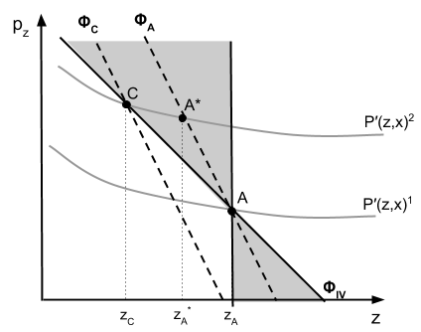

Caption: Under a setting with positive preference stratification, 2SLS and OLS estimation will produce positively biased demand slope estimates. The more negative of the two slope estimates will define an upper bound, while demand theory defines the lower bound by requiring the slope be non-positive. Figure 1 represents a scenario where the 2SLS estimate ($Φ_{IV}$) is more informative than the OLS estimate (not pictured), providing an upper bound for consumer A’s demand function ($Φ_{A}$).

**Figure 2: Wisconsin Counties used in Analysis**

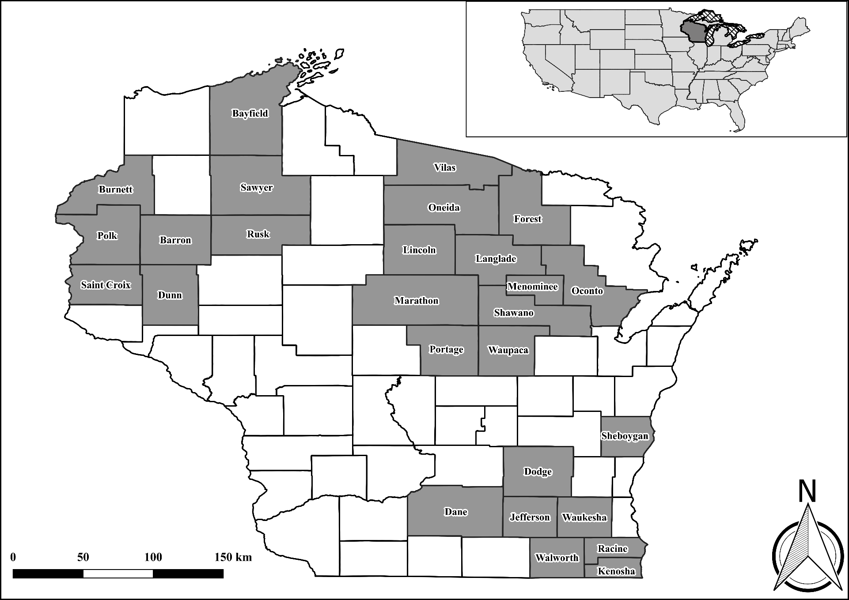

**Figure 3: Minimum Summer Secchi Depth by County**

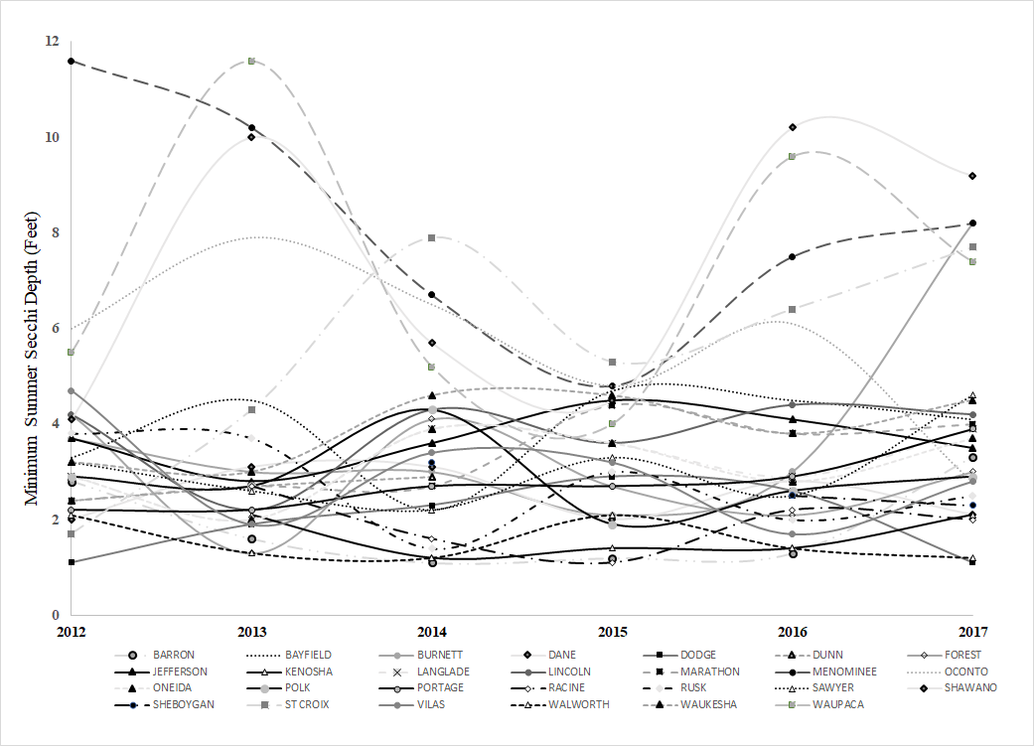

**Figure 4: Wisconsin Climate Regions and County Locations**

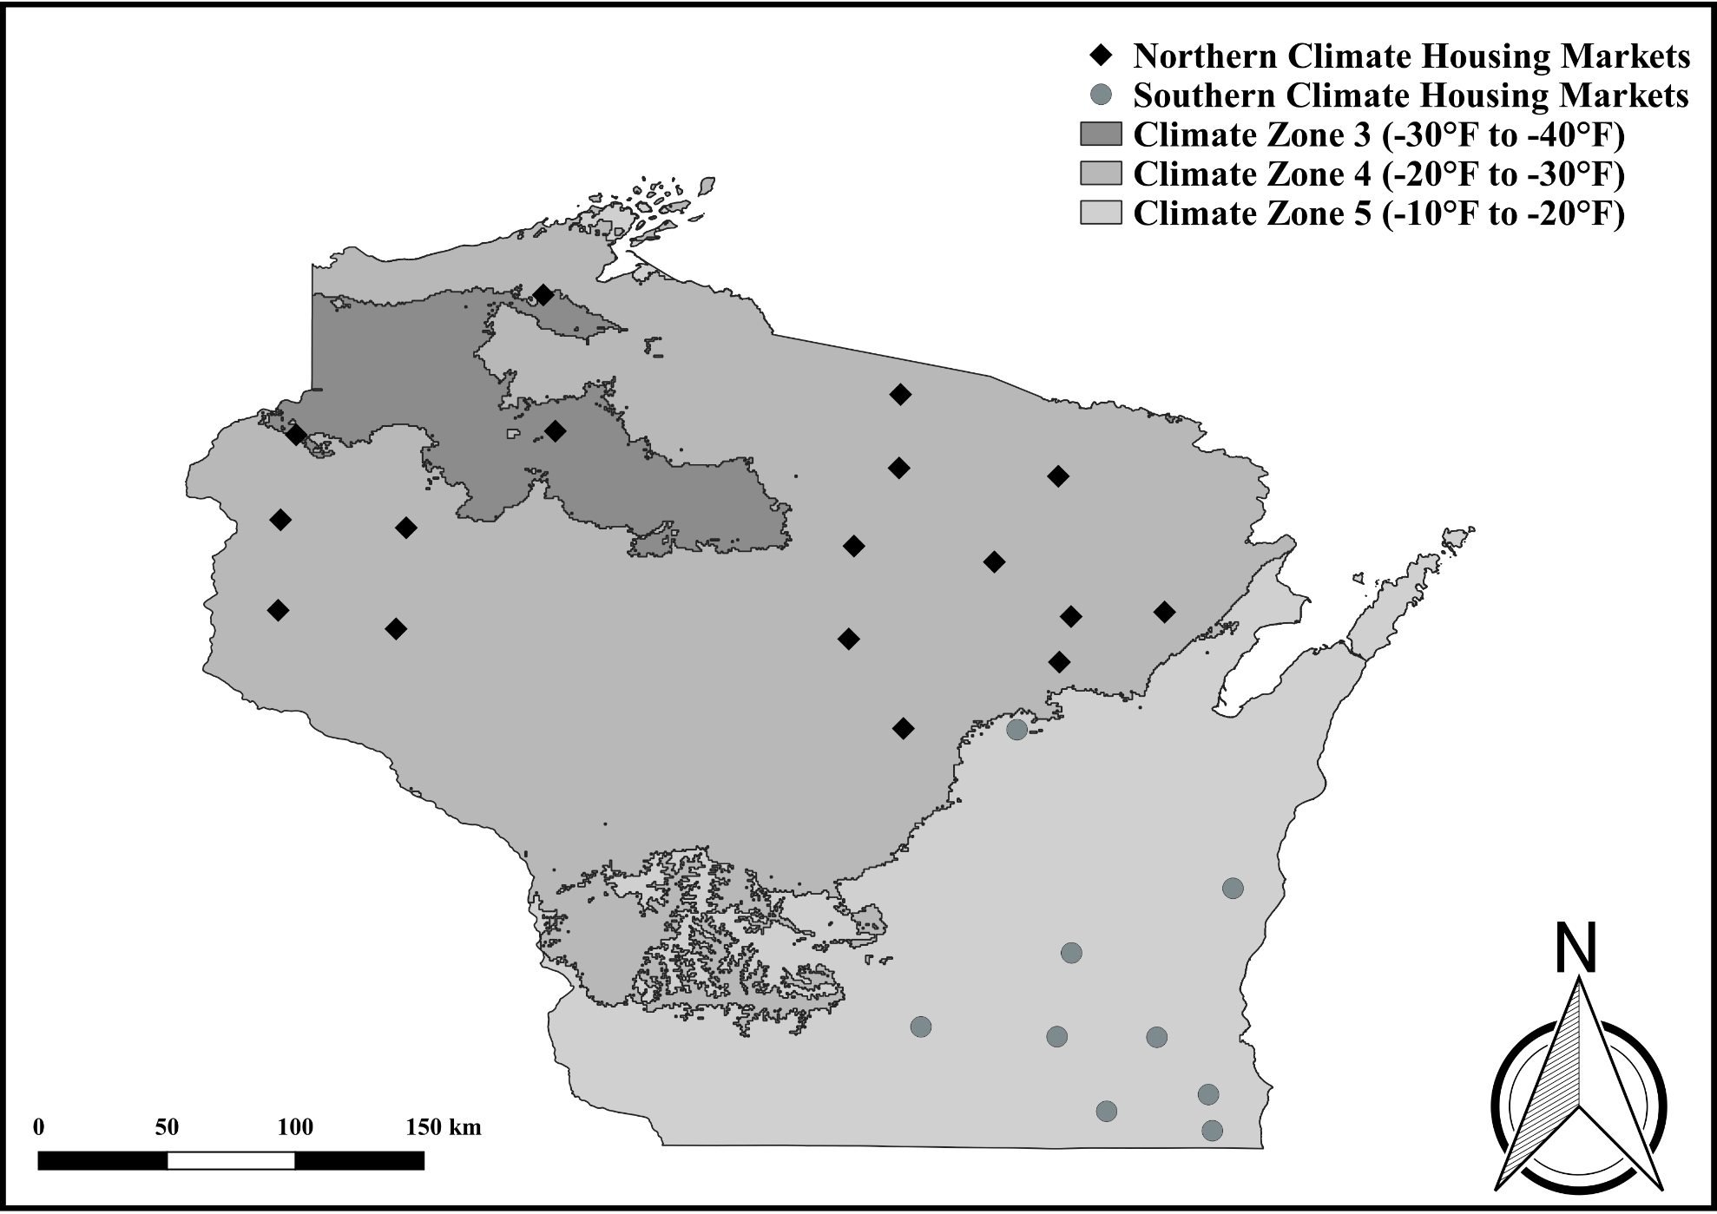

Caption: housing markets are divided into a northern and southern climate region using climate maps from the USDA and PRISM Climate Group. The centroid of each housing market, along with their climate designation, is depicted by a black diamond or a gray circle.

**Appendix A: Bias in Rosen’s Second Stage and the Multimarket Approach**

To illustrate the intuition behind Rosen’s original proposal, consider the following two equations:

(A1) $p_{z}=Φ(z,x, o,μ;π)$

(A2) $p_{z}=Ψ(z,x, ω,ξ;γ)$

where $p_{z}$ is the implicit price for $z$ which is recovered from a first-stage hedonic regression, $z$ is the environmental good of interest[18], and are the inverse demand and supply curves for good $z$ respectively, $x$ is a vector of other attributes that influence the value of the differentiated product, $o$ and $μ$ ( $ω$ and $ξ$) are a vector of observable and unobservable demand (supply) shifters, respectively, and $π$ ( $γ)$ is a vector of parameters that describe the shape and curvature of the demand (supply) function. Equation (A1) characterizes the tangency condition between the hedonic price function and the consumer’s bid curve, while equation (A2) represents the tangency condition between the hedonic price function and the seller’s offer curve.

The set of observable supply shifters, $ω$, become instrumental variables for the endogenous quantity variable $z$ within equation (A1) when simultaneously estimating both equations. This is equivalent to shifting the supply curve to trace out the demand curve under a system of supply and demand equations. However, shifts in the supply curve induce shifts in the demand curve in a hedonic setting (Bartik, 1987). Nonmarket good demand functions derived from this process are, in other words, biased as they are identified from movements between hedonic equilibria and not from movements along a common bid function. We can see the bias resulting from Rosen’s 2nd stage proposal in Figure A1.

Suppose we observe the consumption decisions of two individuals - A and B - who live in the same market defined by the hedonic price equilibria ${P(z, x)}^{1}$ and its derivative ${P'(z, x)}^{1}$. Further suppose the goal of the modeler is to estimate the slope of consumer A and B’s demand function ( $Φ_{A}$ and $Φ_{B}$) and that, from the modeler’s perspective, consumers A and B have identical preferences based on their observable characteristics. When estimating equation (A1) using Rosen’s methodology, the slope of the demand function $\hat{π_{z}}$ is identified off movements along the same hedonic price gradient – ${P'(z, x)}^{1}$– rather than along a shared demand curve. This is problematic as movements from one hedonic equilibrium to the next also correspond to a shift in consumer preferences. Using the two individuals in our example, a movement from point A to point B would represent not only a variation in the amount of $z$ that is consumed but also a change in the type of individual consuming $z$. Individual B in this case has weaker preferences for attribute $z$ than individual A given their inwardly shifted demand curve. The estimated slope of Rosen’s demand function will therefore be identified from variation in $z$ and variation in $μ$ (unobserved consumer preferences), preventing us from identifying the true relationship between WTP and $z$.

One approach to overcome this problem is to gather data from multiple markets. Let point C represent the additional data that is collected from an individual living in a different market defined by the hedonic price equilibria ${P(z, x)}^{2}$ and hedonic price gradient ${P'(z, x)}^{2}$. Once again assume from the modeler’s perspective that consumers A, B and C have identical preferences based on their observable characteristics. The multimarket identification strategy can provide an accurate estimate of consumers A and C’s shared demand function if multiple, unique hedonic price gradients exist (i.e. ${P'(z, x)}^{1}$ and ${P'(z, x)}^{2}$ in Figure A1) and unobserved consumer preferences are randomly distributed across markets. Under this scenario, differing amounts of $z$ will be chosen by two consumers with identical preferences because of the distinct hedonic price gradients they face within their respective markets. This, in turn, allows us to isolate the impact that attribute $z$ has on an individual’s WTP while holding unobserved preferences constant. Curve $Φ_{IV}$ in Figure A1 represents the shared demand function between consumers A and C that is recovered when market dummies are employed as an instrumental variable for environmental good $z$.

This identification strategy hinges on the assumption that preferences are randomly distributed across markets, however, which is unlikely in most hedonic settings. Specifically, when individuals sort themselves into distinct communities, they obtain higher levels of utility by moving to communities where the bundle of public goods provided closely resembles their own utility-maximizing choice. As a result of sorting behavior, individuals reveal their preferences for public goods through their location decisions and form communities where individuals with similar preferences live next to each other (Tiebout, 1956). Random assignment of unobservable preferences is therefore unlikely to hold, leading to bias in multimarket hedonic approaches.

Figure A2 shows the potential bias that results from sorting. Movements across markets are correlated with changes in the distribution of consumer preferences causing the instrumented slope estimates to be biased. In Figure A2 this is apparent when we compare the recovered slope estimates and true demand functions for consumers A and C. Under this scenario we mistakenly assume consumers A and C operate on the demand curve $Φ_{IV}$ given their shared observable characteristics. However, consumers living in market one have systematically stronger preferences to consume environmental good $z$ as compared to their counterparts living in market two.[19] Observably identical consumers living in two different markets, in other words, likely possess separate demand functions for attribute $z$ ( $Φ_{A}$ and $Φ_{C}$ in Figure A2). Between-market variation in attribute prices is therefore correlated with unobserved preferences causing the slope parameter to be biased as variation in $z$ cannot be identified separately from the variation in $μ$.

**References**

Bartik, T. J. (1987). The estimation of demand parameters in hedonic price models. *Journal of political Economy*, *95*(1), 81-88.

Rosen, S. (1974). Hedonic prices and implicit markets: product differentiation in pure competition. *Journal of political economy*, *82*(1), 34-55.

Tiebout, C. M. (1956). A pure theory of local expenditures. *Journal of political economy*, *64*(5), 416-424.

**Figure A1: Intuition behind Multimarket Second Stage Hedonics**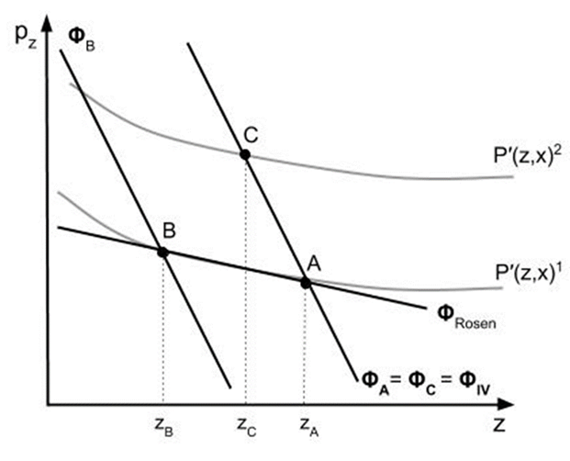

**Figure A2: Bias Produced from a Multimarket Second Stage Hedonic**

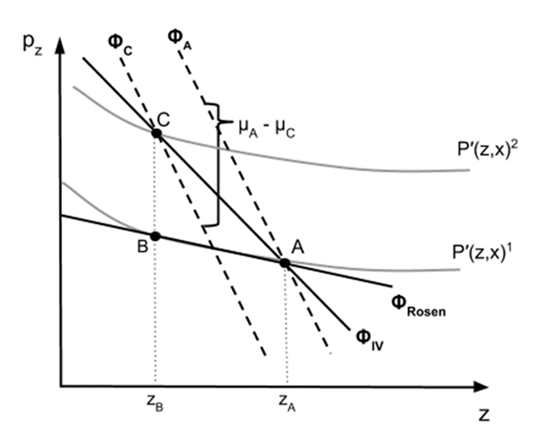

**Appendix B: Additional Tables and Figures**

**Table B1: Housing Summary Statistics for All Homes**



**Table B2: Implicit Price Estimates for a One-Foot Change in Secchi Depth**



**Table B3: Water Clarity Implicit Prices within the Literature**



**Table B4: First-Stage Robustness to Tract Fixed Effects**



**Table B5: First-Stage Robustness to Spatial Threshold**



**Table B6: IV First-Stage Regression Results for Models 2 and 3**



**Appendix C: Water Clarity Data**

In this appendix, we provide a detailed description of the WDNR water clarity data and discuss how it is used to form a household measure of Secchi depth. We also mention some of the benefits of using satellite-derived water clarity measures at the end.

Remote sensing water clarity data is gathered from the WDNR Surface Water Integrated Monitoring System. Lakes across the state are photographed biweekly as the typical satellite launched by the Landsat program revisits any location once every 16 days (Gurlin and Greb, 2016). Lake-wide estimates of Secchi depth are then derived from raster images with a spatial resolution of 30 meters by 30 meters by the WDNR. Secchi depth estimates are only available between the months of June and October due to ice and snow coverage. In addition, although lakes are photographed biweekly, Secchi depth measures are not available every two-week period due to cloud coverage and interference caused by foreign objects (i.e. watercraft, recreationalists, etc.).

The average lake in our study area was sampled 17.18 times with a standard deviation of 9.89. Panel A of Appendix Figure C1 reports the frequency of sampling across all lakes in the study area, while the total number of samples available each year is displayed in panel B. Overall, there were 2,113 Secchi depth estimates available across 123 lakes between the years of 2012 and 2017.

We formed a household measure of water quality by taking the minimum Secchi depth measure from the nearest lake during the summer prior to the housing sale. Housing sales that occurred between June and December were assigned a value using water clarity readings taken during the year of the sale, while transactions occurring between January and May were assigned the minimum summer Secchi depth value from the preceding year. Other methods to attach water quality to property transactions were tested, including using a rolling 12- and 36-month average as well as an annual mean measure. Our results are robust to these aggregation strategies.

***Remote-sensing versus in situ Secchi depth data***

Remote sensing technology has improved since the early 2000s and is now capable of providing reliable estimates of water clarity across large areas. Initially, the level of agreement between satellite and ground-based measures of Secchi depth was poor ( $r^{2}$ = 0.43) as satellite imagery was not well-suited to monitor more than one lake (Nelson et al., 2003). Improvements in imaging technology and data calibration have led to significantly higher correlations between the two, with goodness-of-fit measures ranging between 0.80 and 0.90. This is even observed in study areas with thousands of lakes and where decades of *in situ* sampling data is available (Olmanson et al., 2008; Hicks et al., 2013).

Applications of remote sensing data within the water quality valuation literature have become more common due in part to this improvement. Remote-sensing water quality data has been linked to property values (Moore et al., 2011; Wolf and Kemp, 2021) and recreation data (Angradi et al., 2018;Wolf et al., 2017; Wolf et al., 2019) to better understand the economic benefits of freshwater bodies. In a study comparing the effectiveness of satellite vs ground-based measures of Secchi depth within hedonic pricing models, Wolf and Kemp (2021) find satellite estimates provide a better statistical fit of housing price than ground-based measures. Implicit prices of water clarity also increased by 11% when satellite measures were used in place of *in situ* data. Given the improvement in satellite imaging technology, use of remote-sensing data in other water quality valuation studies, and findings observed by Wolf and Kemp (2021), we do not find evidence that remote-sensing water clarity data is less reliable than more traditional ground-based measures.

**References**

Angradi, T.R., Ringhold, P.L., and Hall, K. (2018). Water clarity as indicators of recreational benefits provided by U.S. lakes: Swimming and aesthetics. *Ecological Indicators*, *93*(Oct.), 1005-1019.

Gurlin, D., & Greb, S. (2016). *Wisconsin Lake Water Clarity Image Processing Protocol for the 2016 Landsat 8 OLI and Landsat 7 ETM+ Images*. Madison, WI: Wisconsin Department of Natural Resources.

Hicks, B. J., Stichbury, G. A., Brabyn, L. K., Allan, M. G., & Ashraf, S. (2013). Hindcasting water clarity from Landsat satellite images of unmonitored shallow lakes in the Waikato region, New Zealand. *Environmental Monitoring and Assessment, 185*(9), 7245-7261.

Moore, R., Provencher, B., & Bishop, R. C. (2011). Valuing a spatially variable environmental resource: reducing non-point-source pollution in Green Bay, Wisconsin. *Land Economics, 87*(1), 45-59.

Nelson, S. A., Soranno, P. A., Cheruvelil, K. S., Batzli, S. A., & Skole, D. L. (2003). Regional assessment of lake water clarity using satellite remote sensing. *Journal of Limnology, 62*(1s), 27-32.

Olmanson, L. G., Bauer, M. E., & Brezonik, P. L. (2008). A 20-year Landsat water clarity census of Minnesota's 10,000 lakes. *Remote Sensing of Environment, 112*(11), 4086-4097.

Wolf, D., Georgic, W., & Klaiber, H. A. (2017). Reeling in the damages: Harmful algal blooms' impact on Lake Erie's recreational fishing industry. *Journal of environmental management*, *199*, 148-157.

Wolf, D., Chen, W., Gopalakrishnan, S., Haab, T., & Klaiber, H. A. (2019). The Impacts of Harmful Algal Blooms and E. coli on Recreational Behavior in Lake Erie. *Land Economics*, *95*(4), 455-472.

Wolf, D., Kemp, T. (2021). Convergent Validity of Satellite and Secchi Disk Measures of Water Clarity in Hedonic Models. *Land Economics*, *97*(1).

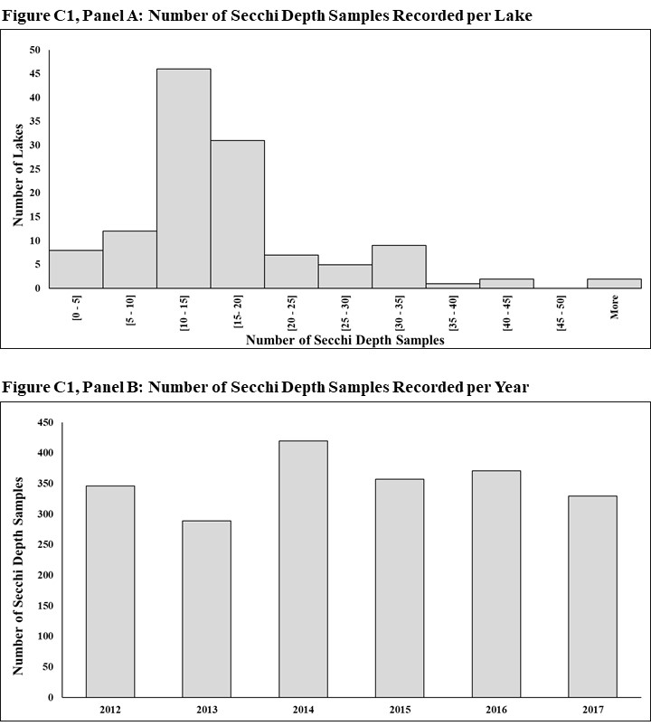

**Appendix D: Alternative Second-Stage Specifications**

Near lake households are expected to like or at least be indifferent towards water clarity improvements. Some of the hedonic price equilibria predicted a negative relationship between housing price and water clarity, however, which led to the recovery of negative implicit prices. In our baseline model (Table 3) we imposed the intuitive restriction that households were at least indifferent towards water clarity change by setting all negative implicit prices to zero, which is akin to how Day et al. (2007) and Netusil et al. (2010) address this problem.

We test how sensitive our results are to this decision by (1) dropping observations with negative implicit prices and (2) leaving the original implicit prices unaltered. The results from these auxiliary regressions are provided in models D1 - D6 in Table D1. The decision to remove imprecisely estimated water clarity prices does not significantly change the demand slope parameter, with the updated estimate (-2,637) less than one standard error away from the baseline measure (-2,087). Similarly, the inclusion of negative implicit prices (models D4 – D6) does not substantially alter the demand slope estimate either. Since the treatment of incorrectly-signed implicit prices does not appear to have a meaningful impact on the slope of the demand function, we continue to set negative implicit prices to zero as we suspect households are at least indifferent, rather than opposed, to water clarity improvements. In our baseline model we also do not drop any implicit prices derived from insignificant estimates as these observations may be important when identifying the choke price for water quality (Zhang et al., 2015).

An additional concern is the spatial extent of water clarity’s impact on household well-being. There is not a consensus within the literature as to how far this spatial threshold should extend. Some studies limit water clarity’s impact to only lake adjacent homes (Boyle et al., 1999; Gibbs et al., 2002; Zhang et al., 2015), while others have extended the threshold to 500 meters (Wolf and Klaiber, 2017), 1000 meters (Walsh et al., 2011; Liu et al., 2019) or even as far as 1500 meters away (Liu et al., 2017). In our baseline specification we employ a 500-meter spatial threshold; however, we test this assumption by extending and reducing the spatial threshold by 250 meters to determine how the slope of the demand function evolves across space.[20]

Coefficients from the 2SLS specification that uses $W_{1}$ as an instrumental variable are provided in columns 2, 5, and 8, while the specification that uses $W_{2}$ is reported in columns 3, 6, and 9 of Table D2. Compared to the baseline model (model 3), the demand functions derived using a larger spatial threshold have a flatter slope. The slope of the demand curve is driven towards zero as more households with weaker preferences for water clarity are added to the second stage. For households who are unaffected by water clarity change (i.e. households who do not have year-round lake access or are not within line-of-sight of a lake), their WTP is zero regardless of the ambient conditions of the nearby lake. By extending the spatial buffer, we are diluting the second-stage sample with these household types. To avoid attenuation bias, we continue to employ a 500-meter threshold as recommended by Wolf and Klaiber (2017) given the similarity in study areas.

A final concern is defining the appropriate extent of market within the first stage. As Parmeter and Pope (2013) point out, no metric exists which can guide us in this decision. Smaller housing market definitions will lead to implicit prices that are estimated with less bias but more variance, while larger housing markets will do the opposite. The goal therefore is to strike the right balance between the two (Parmeter and Pope, 2013). We move towards both ends of this spectrum by redefining housing markets using HUC10 watershed delimiters, which are smaller than counties, and commuting zones which extend across county boundaries (ERS, 2019). We re-estimate models 1 – 3 using these different market definitions and report the results in Table D3.

The most informative slope estimate from the commuting zone specification (-1,942) falls between the slope coefficients from model 2 and model 3 which are -1,879 and -2,087, respectively. Re-defining housing markets using watershed delimiters suggests the slope of the demand function (-1,118) is flatter, however. This is likely due to greater imprecision in the first stage (Parmeter and Pope, 2013). We find this to be the case, with the standard deviation of implicit prices increasing from 7,427 to 8,617 when moving from commuting zone to HUC10 market definitions.[21] This is likely attenuating the slope coefficient towards zero as the dependent variable is measured with greater error.

**References**

Boyle, K. J., & Taylor, L. O. (2001). Does the measurement of property and structural characteristics affect estimated implicit prices for environmental amenities in a hedonic model?. *The Journal of Real Estate Finance and Economics,* 22(2-3), 303-318.

Day, B., Bateman, I., & Lake, I. (2007). Beyond implicit prices: recovering theoretically consistent and transferable values for noise avoidance from a hedonic property price model. *Environmental and Resource Economics*, *37*(1), 211-232.

Economic Research Service (ERS). (2019). *Commuting Zones and Labor Market Areas*. Retrieved from https://www.ers.usda.gov/data-products/commuting-zones-and-labor-market-areas/.

Gibbs, J. P., Halstead, J. M., Boyle, K. J., & Huang, J. C. (2002). An hedonic analysis of the effects of lake water clarity on New Hampshire lakefront properties. *Agricultural and Resource Economics Review*, *31*(1), 39-46.

Liu, T., Opaluch, J. J., & Uchida, E. (2017). The impact of water quality in Narragansett Bay on housing prices. *Water Resources Research*, *53*(8), 6454-6471.

Liu, H., Gopalakrishnan, S., Browning, D., & Sivandran, G. (2019). Valuing water quality change using a coupled economic-hydrological model. *Ecological economics*, *161*, 32-40.

Netusil, N. R., Chattopadhyay, S., & Kovacs, K. F. (2010). Estimating the demand for tree canopy: a second-stage hedonic price analysis in Portland, Oregon. *Land Economics*, *86*(2), 281-293.

Parmeter, C. F., & Pope, J. C. (2013). Quasi-experiments and hedonic property value methods. In *Handbook on experimental economics and the environment*. Edward Elgar Publishing.

Walsh, P. J., Milon, J. W., & Scrogin, D. O. (2011). The spatial extent of water quality benefits in urban housing markets. *Land Economics*, *87*(4), 628-644.

Wolf, D., & Klaiber, H. A. (2017). Bloom and bust: Toxic algae's impact on nearby property values. *Ecological Economics*, *135*, 209-221.

Zhang, C., Boyle, K. J., & Kuminoff, N. V. (2015). Partial identification of amenity demand functions. *Journal of Environmental Economics and Management*, *71*, 180-197.

**Table D1: Sensitivity to Alternative Implicit Prices Definitions**



**Table D2: The Impact of Spatial Extent on Demand Preferences for Water Clarity**



**Table D3: Robustness to Housing Market Definition in First-Stage**



1. * Corresponding author: Assistant Professor at Kobe University, Graduate School of Economics

   Address: Frontier Hall for Social Sciences, Room 812, Kobe University, Kobe, Japan 657-0013

   Telephone: 078-803-7245

   E-mail address: wolf@econ.kobe-u.ac.jp
2. ** The authors are, respectively, Professor ([Klaiber.16@osu.edu](mailto:Klaiber.16@osu.edu)) and Associate Professor ([Gopalakrishnan.27@osu.edu](mailto:Gopalakrishnan.27@osu.edu)) at The Ohio State University, Department of Agricultural, Environmental, and Development Economics.
3.
4. We use the terms water clarity and water quality interchangeably throughout the text as we are interested in how the average household perceives water quality change.
5. Note that $\hat{ΔCS}= ΔCS$ when evaluating marginal changes away from the mean water quality level. In addition, it is possible for the bounded slope estimate to also be the true slope of the demand function, which is why non-strict inequalities are used in equations (6) and (7).
6. A more detailed description of this merging process as well as the WDNR data is given in Appendix C.
7. County boundaries are one of the most common methods to delimit samples within the hedonic literature (Bajari and Kahn 2008; Parmeter and Pope 2013; Bishop et al. 2020) as housing records are collected, maintained, and reported to the public by county assessors. The WDR database is no exception as county auditors first record housing transactions before filing an annual report to the WDR. This causes differences in data coverage at the county level and makes county boundaries a natural divider when defining our sample. As a robustness check, we redefine our first-stage markets using smaller and larger spatial boundaries and discuss these results in Appendix D.
8. We omit smaller lakes (<5 acres) from the analysis as many of them do not have a public access point (Wisconsin Department of Natural Resources 2016) or an active housing market nearby (Wolf and Kemp 2021). We also omit larger lakes (>5000 acres) because of the additional unobservables associated with these waterbodies. Lake Winnebago in southeastern Wisconsin, for instance, is the largest inland lake in Wisconsin and brings in over $300 million to the region each year from recreational fishing activities (University of Wisconsin-Oshkosh Sustainability Institute 2020), which is unlike any other lake in the state. Inclusion of these outlier lakes, however, does not provide qualitatively different findings than those discussed in Section V.
9. Sawyer County had more area in climate zone 3 (-30°F to -40°F) than climate zones 4 and 5. We classified Sawyer County into climate zone 4 as there are not enough observations to identify a bounded demand function for the third climate zone. Exclusion of this county does not qualitatively change our findings. It should be noted that the climate boundaries depicted in Figure 4 closely align with climate maps developed by other institutes like the EPA (EPA 2021) and the Department of Energy (DOE 2021).
10. The decision to interact water clarity with lake size is consistent with the literature (e.g., Michael et al. (2000), Boyle and Taylor (2001), Gibbs et al. (2002), Zhang et al. (2015), and Wolf and Kemp (2021)) and with the expectation that implicit prices for water clarity vary with lake size (Walsh et al. 2011). While this decision could confound the effect of water quality with lake size (Gibbs et al. 2002), we do not expect this to be the case as spatial fixed effects absorb 91.4% of the variation in lake size. For lakes in northern Wisconsin the difference between water quality coefficients is also statistically insignificant when lake size is directly included in the model versus indirectly controlled through the use of spatial fixed effects (See Wolf and Kemp 2021 for more details).
11. Inclusion of non-near lake homes in the first stage allows us to better identify coefficients on peripheral variables such as square footage, number of bathrooms and age and estimate a hedonic price surface for the entire housing market, while the near lake subsample in the second stage allows us to focus on the segment of the market that is influenced by water clarity changes.
12. Robust standard errors were clustered at the census tract level in all markets except Menominee county where wild bootstrap standard errors were employed due to the limited number of clusters (Cameron et al. 2008).
13. Observations with negative implicit price values are assigned a value of zero in our baseline second-stage model. Similar practices have been employed by Netusil et al. (2010) and Day et al. (2007). We assess the impact of this decision in Appendix C.
14. The rank-based instruments are also updated to reflect how water quality conditions vary across county-specific markets within each region rather than across the pooled sample, with each climate region having a county with the worst ranked water quality, a county with the second worst water quality, and so forth.
15. Our water clarity data also supports this conclusion, with the average household experiencing a Secchi depth of 5.53 feet and 4.82 feet in the North and South respectively.
16. As a second source of heterogeneity, we examine whether seasonality impacted households’ WTP. We test this by forming a dummy indicating if the property was sold during the winter (November – February) and interacting that with $WC$ and the instrumental variables. We do not find evidence of seasonal heterogeneity in this specification or in the month dummy coefficients included within our second-stage models.
17. The welfare bias generated from the first-stage is potentially larger than the numbers reported in the text as the true slope of the demand function may be steeper than what we estimate due to our partial identification strategy.
18. Within the second-stage hedonic literature, $P(.)$ is typically used to denote the hedonic price function, $P^{'}(.)$ is the gradient of the hedonic price function with respect to the attribute of interest, and $p_{z}$ is value of the hedonic price gradient evaluated at the observed consumption bundle (i.e. $p_{z}=P^{'}\left(z^{*},x^{*}\right)=\frac{dP(z^{*},x^{*})}{dz}$, where $z^{*}$ and $x^{*}$ are the observed consumption levels of attributes z and x respectively). We keep with tradition and follow this notation in the text.
19. This difference in unobserved preferences is captured by the difference in height between consumer A and C’s demand function: .
20. Note, we re-estimate the hedonic price functions each time a new spatial threshold is employed and then run a pooled second-stage regression using only the homes located within that spatial buffer. See Appendix Table B5 for the first-stage estimates.
21. The average number of housing transactions per market also decreased significantly when HUC10 definitions were used. The average HUC10 watershed had 1,577 housing transactions, while the average commuting zone had 22,806.Several HUC10 housing markets had fewer than 50 near lake housing transactions as well, which caused the first-stage Secchi and lake proximity coefficients to be imprecisely estimated due to multicollinearity. We drop these markets when estimating models D16 – D18, though we note that inclusion of these markets in the second stage still produces a negative and statistically significant slope coefficient.