The Migration Effects of Chinese Returnees on Emigration in the Late 19th Century as Compared to European Migration

FUJIMURA Korekiyo

(Abstract)

By analyzing the passenger traffic statistics of four exit ports – Amoy, Swatow, Kiungchow, and Hong Kong – from 1855 to 1940, this report presents a new perspective on Chinese migration along China’s coast in the late 19th century. Mencarini’s statistical study of three Chinese treaty ports from 1876-1898 has not been carefully examined for over a century. By including statistical data from Hong Kong, which Mencarini did not use, this study presents detailed flow diagrams to highlight the movement of migrants between China and nearly all regions in Southeast Asia and part of North America.

Up until 1928, statistical figures on migration between Chinese coastal cities and Southeast Asian countries or San Francisco in the United States all showed long-term upward trends, except for during World War I when these figures temporarily dropped. The annual return rate to China remained, and the rate was approximately 80 percent, except for between 1931 and 1933. The percentage of women and children leaving China rose to over 50 percent around 1937. The monthly distribution of the number of Chinese entries and departures to and from San Francisco in the three months before and after the Lunar New Year was four and eight times higher than the other months.

This report also discusses why most trends simply show an increase in the number of emigrants in direct proportion to that of immigrants for almost every year. The analytical approaches of previous studies failed to point out the link between the departures and entries of Chinese migrants. This drawback is attributed to the method used, which involves determining the factors affecting migration rates based solely on yearly statistics. The key to explaining the simultaneous annual rise in the number of exiting and entering Chinese migrants is the micro migration cycle, which is most clearly recognized in the monthly movements of Chinese to and from San Francisco.

Each year, former emigrants tended to return to China before February, and new emigrants left for the same destinations after the Chinese Spring Festival. The money and knowledge that these returnees brought back to their local communities in South China attracted others to join the collective emigration to San Francisco. The returnees and settlers from the United States and Southeast Asia were instrumental in bringing Chinese newcomers from their own groups, and upward trends were generally observed. This cycle was the fundamental base of Chinese mass migration.

Lastly, this study statistically compares the migration effects of Chinese returnees on emigration with European returnees’ influence on their respective outflow to the United States. Italian migration cycles between Italy and New York will provide an interesting example from the viewpoint of the Chinese return migration cycle.

(Full Paper)

The Migration Effects of Chinese Returnees on Emigration in the Late 19th Century as Compared to European Migration

FUJIMURA Korekiyo

Contents

*Introduction*

*Ⅰ．Passenger Traffic Statistics of the Four Chinese Exit Ports*

*(1) Departures and Arrivals to and from Outside China*

*(2) Singapore Statistics, Prepared and Verified*

*Ⅱ．Return Rates*

1. *Total Return Rates*
2. *Monthly Return Rates (San Francisco)*

*Ⅲ．Migration Cycle*

*Conclusion*

*Introduction*

By analyzing the passenger traffic statistics of four exit ports – Amoy, Swatow, Kiungchow, and Hong Kong – from 1855 to 1940, this paper presents a new perspective on Chinese migration along China’s coast in the late 19th century.

Mencarini ［1901］

Amoy

Swatow

Kiungchow

Hong Kong



Fujimura［2009, 2010］





1855

Chart 1 Coverage of the Period of Chinese Migration

Source：Fujimura [2012：97, 101]

Mencarini’s statistical study of three Chinese treaty ports from 1876-1898 has not been carefully examined for over a century. By including statistical data from Hong Kong, which Mencarini did not use, this study presents detailed flow diagrams in order to highlight the movement of migrants between China, nearly all regions in Southeast Asia, and part of North America.

*Ⅰ．Passenger Traffic Statistics of the Four Chinese Exit Ports*

*(1) Departures and Arrivals to and from Outside China*

Chart 2, below, showing annual departures to and arrivals from each destination outside of China, 1855-1940, uncovers the following points. Up until 1928, statistical totals on migration between Chinese coastal cities and Southeast Asian countries or the U. S. A. and Canada showed long-term upward trends, except for during World War I when these figures temporarily dropped. The annual return rate to China remained steady at approximately 80%, except for the period between 1931 and 1933.



Chart 2 Annual Departures to and Arrivals from Each Destination (1855-1940)

Source：Table 2, below.

Table 1. Departures from and Arrivals to Each Exit Port (1855-1940)



Source：Fujimura [ 2010：130；2017, in Yoshihara (ed.), forthcoming ].

Table 2 Departures to and Arrivals from Each Destination (1855-1940)



Source：Fujimura [ 2017, in Yoshihara (ed.), forthcoming ].

*(2) Singapore Statistics, Prepared and Verified*

Tables 3 and 4 show the the statistics regarding Singapore. Table 3, below, verifies the Singapore statistics prepared by this author, as shown in Table 4 on the next page.

In Table 3, it can be seen that almost all of the rightmost I/J figures, are near 1.00, indicating that the method used here to count the statistics is generally adequate.

Table 3 Verification of Singapore Statistics



Source：Fujimura[2012：110]

Table 4 Preparing the Singapore Statistics

Source：Fujimura［2012：107］

*Ⅱ．Return Rates*

*(1)Total Return Rates*

Chart 3, below, shows the return rates of each exit port and each foreign destination. The five left-hand sets of bars show the departures and arrivals of each exit port and the total, while the nine right-hand sets of bars show the departures and arrivals to and from each destination and the total.



French

Indochina

Total

Total

Hong

Kong

Singapore

U. S. A.

Thailand

Amoy

Dutch

East

Indies

Canada

Swatow

Philip-pins

Others

Kiung

chow

    

Chart 3 Total Return Rates (1855-1940)

Source：Tables 1 and 2, above.

It is important to note that the leftmost Hong Kong departures bar is lower than the arrivals one, and the number of arrivals to Hong Kong was 1.21 times as many as the number of departures. Conversely, every arrivals bar for the other three ports is much lower than the respective departures bar. For example, the return rate of Swatow is only 35.96%. The contrast between the return rate of Hong Kong and those of the other three ports is due to the special character of Hong Kong as a home-coming port. Many of the emigrants from the other three ports, Amoy, Swatow and Kiungchow, returned home via Hong Kong, because they could easily exchange foreign currencies into Chinese currency and could buy gifts for their family and community in Hong Kong.

Turning our attention to the right-hand bars, all departures bars are longer than the arrivals ones, and, generally, most of the return rates are not far from 80%.

1. *Monthly Return Rates (San Francisco)*

This paper also discusses why most of the trend lines show an increase in the number of emigrants in direct proportion to that of immigrants for almost every year, as shown in annual return rates in Table 1 and Chart 2. The analytical approaches of previous studies failed to point out the link between the departures and entries of Chinese migrants. This drawback is attributed to the method used, which involves determining the factors affecting migration rates based solely on yearly statistics.



●February

Hong Kong→San Francisco

San Francisco→Hong Kong

Chart 4 Monthly Departures to and Arrivals from San Francisco (1855-1895)

Source：Fujimura［2013：64］

*Ⅲ．Migration Cycle*

The main focus of this study is to illustrate that the micro migration cycle between China and San Francisco presents a universal and principal trend that developed worldwide in the late nineteenth century.

The key to explaining the simultaneous annual rise in the number of exiting and entering Chinese migrants is the micro-migration cycle, which is most clearly recognized in the monthly movements of Chinese to and from San Francisco, shown in the Charts 4 and 5.

The monthly distribution of the number of Chinese entries and departures from and to San Francisco in the three months before and after the Lunar New Year was four and eight times higher than the other months.



February

Chart 5 Average Monthly Departures to and Arrivals from San Francisco

Source：Fujimura [2013：66]

It is necessary to statistically compare the migration effects of Chinese returnees on emigration with European returnees’ influence on their respective outflow to the United States. Italian migration cycles between Italy and New York will provide an interesting example from the viewpoint of the Chinese return migration cycle [Ferenczi, I., and W.F. Willcox (1969. [1929, 1931]): 462-463; 477].

*Conclusion*

Each year, former emigrants tended to return to China before February, and new emigrants left for the same destinations after the Chinese Spring Festival. The money and knowledge that these returnees brought back to their local communities in South China attracted others to join the collective emigration to San Francisco. The returnees and settlers from the United States and Southeast Asia were instrumental in bringing Chinese newcomers from their own groups, and upward trends were generally observed. This cycle was the fundamental basis of Chinese mass migration.

Appendices



Appendix 1. Hong Kong (1855-1939)

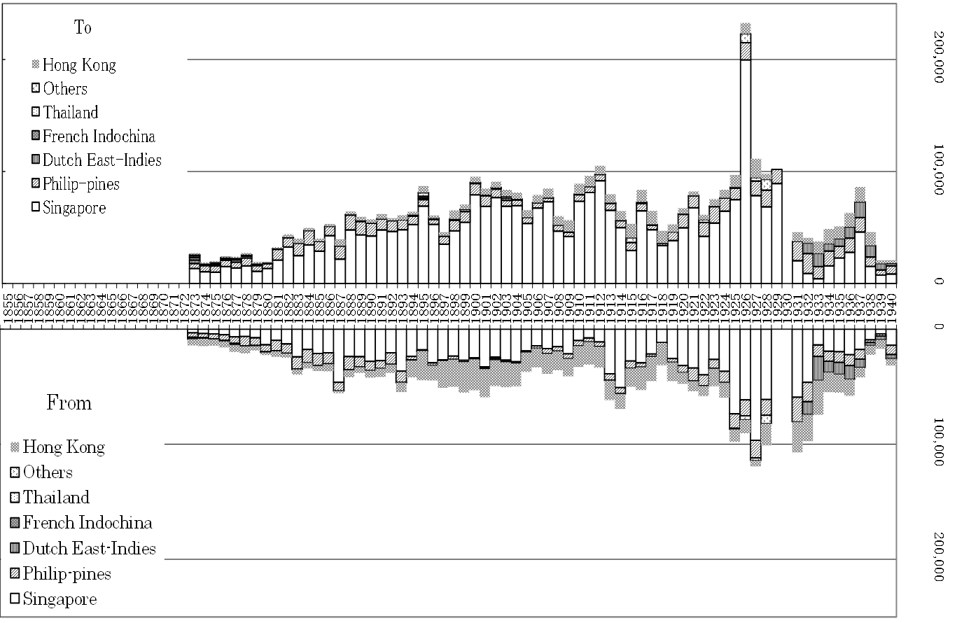

Appendix 2. Amoy (1873-1940)

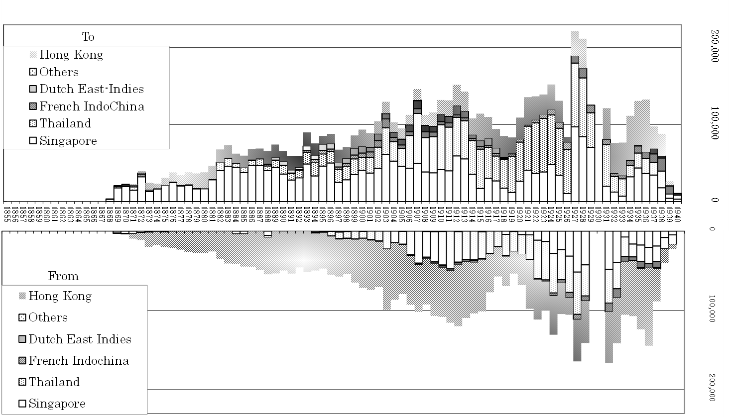

Appendix 3. Swatow (1868-1940)

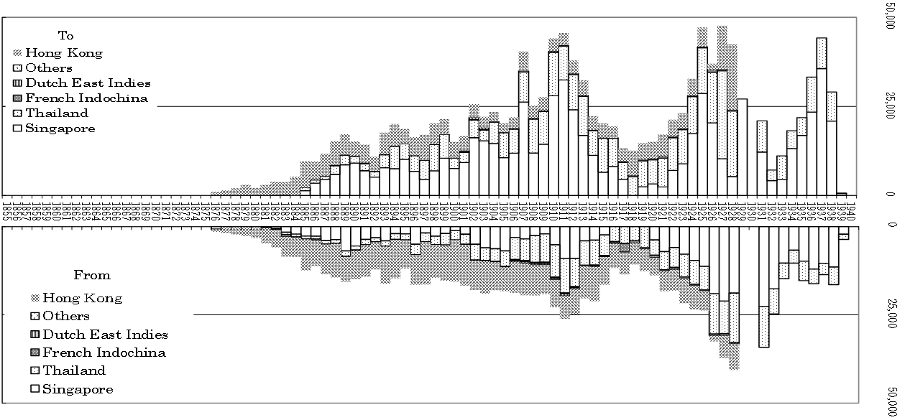

Appendix 4. Kiungchow (1876-1940)

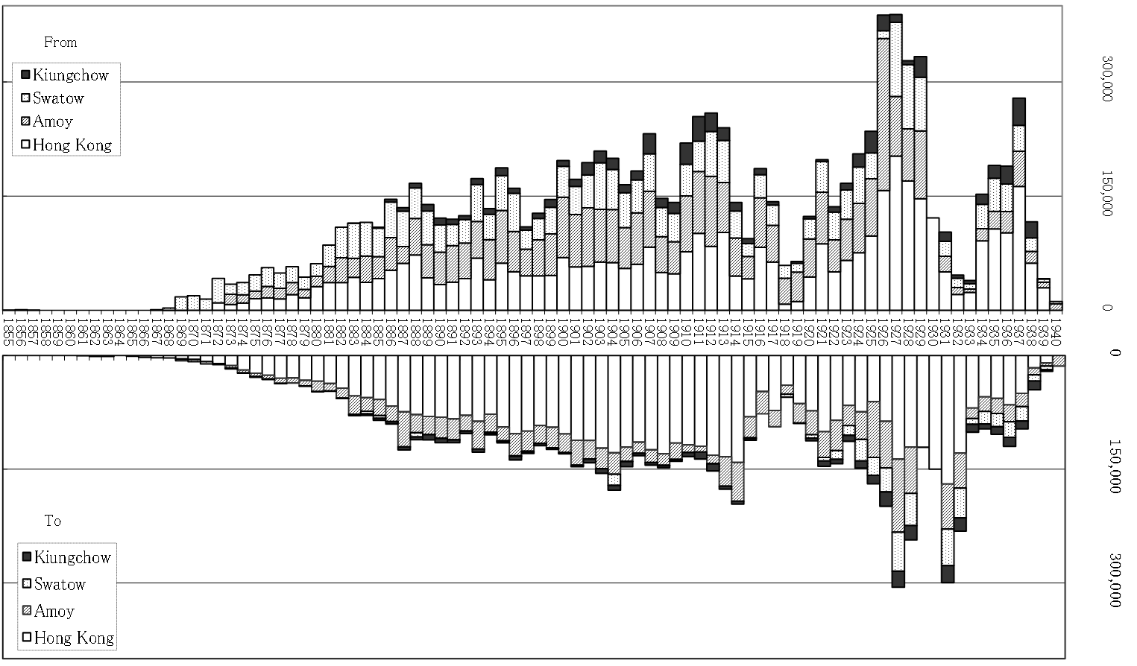

Appendix 5. Singapore / Straits Settlements (1855-1940)



Appendix 6. Thailand (1855-1940)



Appendix 7. Dutch East-Indies (1855-1940)



Appendix 8. U. S. A. (1855-1939)



Appendix 9. Canada (1855-1939)



Appendix 10. U. S. A. and Canada (1855-1939)



Appendix 11. Annual Departures from and Arrivals to Each Exit Port (1855-1940)

References

CMC：China, Imperial Maritime Customs/ Maritime Customs.

CMC*Reports*：*Reports on Trade at the Treaty Ports in China, for the year…1864*,*1865*-*1866. 1870*, *1871-1872*, *1873*-*1881* .

CMC*Gazette* ： *Customs Gazette 1873, Jan.-Mar* ; *1881, Oct.-Dec.* .

CMC*Returns* ： *Returns of Trade at the Treaty Ports in China for the year 1873*, *1874*, *1875*, *1877*, *1878*, *1879*, *1881*.

CMC*R&R*： *Returns of Trade at the Treaty Ports, and Trade Reports, for the year 1882*-*1922.*

CMC*Annual* ： *Annual Report and Returns*, *1923*-*1926*）.

*Amoy Annual Trade Report and Returns*.

*Swatow Annual Trade Report and Returns*.

*Kiungchow Annual Trade Report and Returns*.

CMC*Foreign Trade* ： *Foreign Trade of China,…1929*-*1931.*.

*Foreign Trade of China, Annual Trade Report and Returns*, *1927*-*1928*.

*Foreign Trade of China*, *1929*-*31*.

*Amoy Annual Trade Returns*.

*Swatow Annual Trade Returns*.

*Kiungchow Annual Trade Returns*.

CMC*Trade* ： *The* *Trade of China*.

CMC*DR*：*Decennial Reports …1882-1891*, *1892-1901*, *1902-1911*, *1912-1921*, *1922-1931*.

CMC*Documents*：*Documents illustrative of the Origin, Development, and Activities of the Chinese Customs Service* 1-7. 1937-1940.

HK：Hong Kong Government.

HK*Abstract*：*Historical and Statistical Abstract of the Colony of Hong Kong 1841-1930, Third Edition*, 1932.

HK*AR*：*Administrative* 〔*Administration*〕*Reports for the year* …*1911*, *1916*, *1918*, *1928*, *1938*.

HK*Gazette* ： *Hongkong Government Gazette*.

HK*Harbour*：*Report of the Harbour Master for the year* …*1855*-*1939*.

SS：Straits Settlements

SS*Annual* ：*Annual Departmental Reports of the Straits Settlements for the year…*1886,1894-1928.

SS*Colony*：*Colony of the Straits Settlements*, 1884-1885, 1887-1890.

Ferenczi,I., and W.F.Willcox (1969 [1929,1931] ) *International Migrations*, 1-2, University Microfilms, Ann Arbor, Michigan: Xerox Company. (first published, New York: National Bureau of Economic Research）

Fujimura, Korekiyo (2015) ‘Reexamining the Statistics of Chinese Steerage Passengers on Pacific Mail Steamship Company Paddle Wheelers, 1867–1871,’ *Kanagawa University Asian Review 2*, Center for Asian Studies, Kanagawa University, pp. 56-68, in Japanese.

――(2013) ‘Reexamining the Cycles of Chinese Migration Based on the Statistical Analysis of Passenger Traffic Data of Four Ports Sending Chinese Overseas, 1855–1940: Beyond the limits of Mencarini Data (Part Two),’ *Journal of Chinese Overseas Studies*, No. 10, 2013, The Japan Society for the Studies of Chinese Overseas, pp. 59-73, in Japanese with English abstract.

――(2012) ‘Reexamining the Cycles of Chinese Migration Based on the Statistical Analysis of Passenger Traffic Data of Four Ports Sending Chinese Overseas, 1855–1940: Beyond the limits of Mencarini Data (Part One),’ *Journal of Chinese Overseas Studies*, No. 9, 2012, The Japan Society for the Studies of Chinese Overseas, pp. 95-129, in Japanese with English abstract.

――(2011a) ‘Transmigration of Overseas Chinese and Chinese New Year Focusing on Immigration Figures of Hong Kong, 1855–1868,’ *Annual Review of Human Sciences*, Vol. 5, March 2011, Kanagawa University, pp. 67-89, in Japanese.

――(2011b) ‘Transition of the Figures of Arrivals and Departures from the Exit Ports for Overseas Chinese, 1855–1940, and the Factors, Based on the Annual Comments of Chinese Customs,’ *Research Bulletin of Musashino Art University,* issue 41, Musashino Art University, pp. 5-17, in Japanese.

――(2009) ‘Chinese Passenger Traffic between South China and Southeast Asia, 1855-1939,’ *Annual Review of Human Sciences,* Vol. 3, March 2009, Kanagawa University, pp. 23-50, in Japanese.

――(1995) ‘Social Conditions of the Chinese Return Migration, Focusing on the Passenger Traffic Statistics of 3 ports in South China, 1876–1938’ in Masuo Tomioka, Heihachi Nakamura (eds.), *Historical Image of the Modern World*, Sekai-Shoin, pp. 131-172, in Japanese.

――(1995) ‘Transition of the Number of Arrivals and Departures of 4 Ports in South China, 1855–1939,’ *Research Annals* (*Kenkyu-Ronshu*), 24, Graduate School of Economics, Kanagawa University, pp. 1-37, in Japanese.

Gottwaldt, H. (1903) *Die überseeische Auswanderung der Chinesen und ihre Einwirkung auf die gelbe und weisse Rasse*, Bremen: Max Nössler.

Lindsay, W. S.（1965［1874, London edition］） *History of Merchant Shipping and Ancient Commerce*, vol. 4, New York: Ams Press.

Mencarini, Juan (1967 [1901]) “The Philippine Chinese Labour Question,” *Journal of the China Branch of the Royal Asiatic Society for the year 1900-1901*, 33: 158-185, Nendeln/Liechtenstein: Kraus Reprint Limited.

Mosolff, Hans (1932) *Die Chinesische Auswanderung: Ursachen, Wesen und Wirkungen*, Rostock: Carl Hinstorffs Verlag.

Pacific Mail Steamship Company (1872) *Burning of the Pacific mail Steam Ship Company’s Steam-ship “America,” in the Harbor of Yokohama, August 24th, 1872. San Francisco Investigation: to which is Added Agent’s Letter to the President of the Company, Report of the Investigation at Yokohama, and Newspaper Report of Same, from the “Japan Herald Mail Summary,”* San Francisco: Pacific Mail Steamship Company.

Skinner, G. William (1957) *Chinese Society in Thailand: An Analytical History*, New York: Cornell University Press.

Thailand, Department of Commerce and Statistics, Ministry of Finance, *Statistical Year Book of the Kingdom of Siam*. 1916-1939.

Yoshihara, Kazuo (ed.) (2017, forthcoming) *The Encyclopedia of the Chinese Overseas*, Tokyo: Maruzen Publishing Co., in Japanese.

United States, Congress (1877) *Report of the Joint Special Committee to Investigate Chinese Immigration*, Washington: Government Printing Office. 　<http://archive.org/details/reportofjointspe00unit/> （Jan. 2nd, 2013）

University of Hong Kong Libraries, *Hong Kong Government Reports Online　(1853-1941)* (HKUL Digital Initiative) <http://lib.hku.hk/database/>（Dec. 28th, 2008）